SUPPLIER RELATIONSHIPS MANAGEMENT

SUPPLIER SELF SERVICE
SUPPLIER LEARNER GUIDE

 | SUPPLIER RELATIONSHIPS MANAGEMENT (SRM) SUPPLIER SELF SERVICE (SUS)
 | SUPPLIERS
 | SRM SUS
 | Type of document:
 | Learner Guide
 | With Facilitator Guidelines
 | Document No. | SRM_SUS_MAT_SRV_NCR_SUPPLIER
 | Course code: | SRM_SUS_MAT_SRV_NCR_SUPPLIER
 | Version number: | V0.5
 | Effective Date: | 30 July 2012
Copyright © Transnet Rail Engineering
©. No part of this document may be reproduced, republished, redistributed, exploited or transmitted in any form or by any means, electronic, including photocopying, recording, or by any information storage and retrieval system, without the express written consent of Transnet Rail Engineering, a Business Unit of Transnet Limited.

Contents
Executive Summary 4
Process Flow 6
Course Overview 7
Chapter 1 Login on the system and password management 13
1.1 Access to SRM SUS 14
1.2 Login on to SRM SUS 15
1.3 Resetting your Password 17
1.4 Browsing the SRM SUS Portal 21
1.4.2 Understanding the screen layout 24
1.5 Changing your own data 25
1.6 Authorisation Access 28
1.7 Managing Supplier Emails 29
Chapter 2 PURCHASE ORDER MANAGEMENT PROCESS 31
2.1 Receiving a Purchase Order from TE 33
2.1.2 New Purchase Orders 34
2.1.3 Confirming your Purchase Order 39
2.1.4 Rejecting your Purchase Order 41
2.1.5 Changed Purchase Orders 43
2.1.6 Making Changes to Purchase Orders 45
2.1.7 Creating Scheduled Deliveries 49
2.1.8 Printing your Purchase Order 52
Chapter 3 ADVANCED SHIPPING NOTIFICATION AND SHIPPING DOCUMENT 54
3.1 Creating an Advanced Shipping Notification (ASN) 56
3.1.2 Printing your ASN 60
3.2 Creating a Shipping Document 63
3.2.2 Printing your Shipping Document 68
3.2.3 Changing a Shipping Document 68
Chapter 4 ASN AND SHIPPING DOCUMENT PRE-RECEIPT PROCESS 69
4.1 Display Pre-Receipt Status for your ASN 71
4.3 Displaying a GRV 74
Chapter 5 SERVICE CONFIRMATION 76
5.1 Create a Confirmation 78
5.2 Viewing a Rejected Confirmation 82
Chapter 6 SUPPLIER NON CONFORMANCE MANAGEMENT 85
6.1 Receiving an NCR 87
Chapter 7 FINANCE – INVOICE AND INVOICE STATEMENT SUBMISSION 93
7.1 Display List of Supplier Invoices 95
7.2 Creating a SUS Invoice for GRV 96
7.2.1.2 Attaching and Invoice and Invoice Statement 99
7.2.2 Creating a SUS Invoice for a Services 101
7.2.2.2 Attaching and Invoice and Invoice Statement 104
7.3 Uploading Statements 106
7.3.2 Displaying Statements 109
7.4 Managing Rejected Invoices and Statements 110
7.4.2 View Accepted Invoices 111
7.4.3 View Rejected Invoices 111
7.5 Checking Payment Statuses on Invoices 113
7.6 The Remittance Advice 115
Chapter 8 BBBEE AND TAX CLEARANCE CERTIFICATES UPLOAD 117
8.1 Uploading BBBEE Certificates 119
8.2 Uploading Tax Clearance Certificate Certificates 122
Chapter 9 TRACKING AND REPORTING 127
9.1 Demand Visibility Report 128
Chapter 10 SRM SUS CALL LOG AND SUPPORT 131
10.1 PDF Attachments 132
10.2 Logging a Call through SRM SUS 133
10.2.2 Attachments 135
10.3 Logging a call with the Help Desk 137
10.4 Escalating Call Response or Issues 137

About this course
Instructional Designer/s | Capacity
Tlale Mosimane | Change Management
Contributors |  | Capacity
Technical Project Team Members | Project team
Umesh Channegowda | SAP SRM Consultant
Thabo Sereko | ICT Logistics Inbound Team Lead

Executive Summary

As part of an on-going effort to improve systems and operating procedures Transnet Engineering (TE) adopted the Lean Six Sigma as a strategy to develop and transform the organisation into an efficient World Class Organisation.

For all the divisions impacted to effectively support and help Transnet meet its targets as a national carrier, TE has to implement world class systems in order to reach its organisational objectives. Supplier Relationships Management (SRM) is one of these initiatives to implement enabling technology to support its vision.

Supplier Relationship Management (SRM) is part of the SAP suite and allows for a comprehensive approach to managing an organisation’s interactions with companies that supply the products and services it uses. It defines “HOW” Transnet Engineering interacts with its supplier. It also integrates policies, procedures, people, processes and collaborative systems to create a supplier facing interface. In the case of TE this supplier facing interface was in the form of Supplier Self Service (SUS). As such the project is always referred to as SRM SUS (Supplier Relationship Management the form of Supplier Self Service).

SRM is primarily a Supply Management function which plays a very critical role in ensuring the procurement of goods and services so that that our organisational objectives are carried out in a seamless manner. SRM allows Supply Management to do this by ensuring that TE strengthened relationships with its suppliers through availability of information and enabling technologies.
In Phase 3, SRM extends the procurement functionality of the solution by including the Logistics (receiving of goods and services) and the payment functions. The entire ‘Procure to Pay’ process is now addressed within the Portal solution, as well as the Quality Management function of the Procure to pay process.

The following benefits from a Supply Management perspective can be expected:
- Enhancement of co-operation and quality of information flows
- Security of supply and leverage through negotiation of better deals from suppliers
- Continuous improvement with suppliers by encouraging innovation
- Compliance with contracts and regulations
- Better risk control through better information flows
- Lean processes and consolidation of supplier base
- Reduction of cycle times and process costs and better value for money
- Improvement of process quality

SAP SRM enables an organisation to:
  - Optimize your procurement strategy
  - Work more effectively with your supplier pool
  - Improve your supplier relationships

- SAP SRM allows an organisation to:
  - Examine and forecast purchasing behavior
  - Shorten procurement cycle
  - Work with your partners in real time
  - Improve efficiency
  - Cut down your procurement expenses
This allows you to develop long-term relationships with all those suppliers that have proven to be reliable partners.

Process Flow
The Process flow below indicates the high level SRM SUS process that has been implemented in TE.
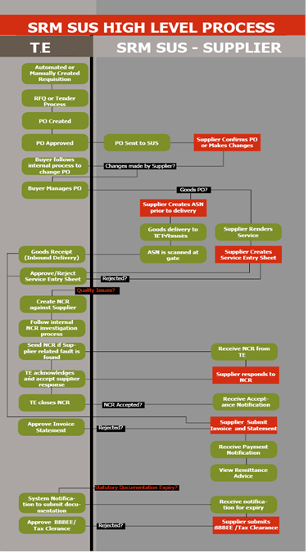
TE

Course Overview
Purpose of the Course
The purpose of the course is to ensure that our Valued Suppliers on SRM SUS understand the end to end process, and are able to complete their expected functions accurately.
Course Prerequisites
You must have completed the following courses successfully before you can attend this course:
Course Code | Course Name
SRM_SUS_OVERVIEW | SRM SUS Overview Course
Course Objectives
- Understand the end to end SRM SUS process;
- Understand the PO Management Processes and how to navigate the related functionality on the portal;
- Understand the Material or Goods Management Processes and how to navigate the related functionality on the portal;
- Understand the Service Management Processes and how to navigate the related functionality on the portal;
- Understand the Finance Processes and how to navigate the related functionality on the portal;
- Understand the Non Conformance Processes and how to navigate the related functionality on the portal; and
- Understand the function of uploading and downloading of documents on the SRM Portal.
Course duration
This is a ½ a day course.
Formative Assessment Method
Exercises will be used at the end of chapters (where relevant) to assess understanding during the course.
Course map
This course consists of the following chapters:
 | Chapter | Description
 | 1 | Login on, Passwords and Authorisation Access
 | 2 | Purchase Order Management
 | 3 | Advanced Shipping Notification and Shipping Document
 | 4 | Service Confirmation
 | 5 | Supplier Non Conformance Management
 | 6 | Finance – Invoice and Invoice Statement Submission
 | 7 | Tracking and Reporting
 | 8 | BBBEE and Tax Clearance Certificates Upload
 | 9 | Tracking and Reporting
 | 10 | SRM SUS Call Log and Support

Icons / Symbols
The following icons / symbols are used in this learner guide:
Symbol | Meaning | Symbol | Meaning
 | Notes |  | Warnings
 | Tips
 | Appendix |  | Bibliography
 | Caution |  | Checklist
 | Executive Overview |  | Facilitator Note
 | In a Nutshell |  | Knowledge Review
 | Learner Notes |  | Looking Back
 | Looking Forward |  | Notes
 | Overview |  | Questions I have
 | Skills Builder |  | T4U
 | Tips |  | Unit Standard
 | Warning |  | What's in it for me.

Abbreviations
Abbreviation | Meaning
AP | Accounts Payable
ASN | Advanced Shipping notification
BBBEE | Broad Based Black Economic Empowerment
NCR | Non-conformance Certificate
SES | Service Entry Sheet
SM | Supply Management (a department within TE)
SRM | Supplier Relationships Management
TE | Transnet Engineering

Acronyms
Acronym. | Meaning
SUS | Supplier Self Service

Blended Resources
The following resources will help you to master the learning outcomes:
Articles
The TE website has various articles about the project. This is located under Supply Management >> SRM and will be available once the project goes live (beginning September 2012)
Consulting
Your facilitator has extensive knowledge; make sure that you utilize them as much as possible.
Internet
The TE website has various articles about the project from 2010.
Systems
Electronic Training Material can be requested from the TE Supplier Support team or can be accessed from portal the home page.

Test for Understanding?
To test your understanding from the Overview Course, please complete the following Questionnaire.
Question 1
SRM stands for Supplier Relationships Management
Answer with True or False.
A. | TRUE |  |  | B. | FALSE

Question 2
SUS stands for Supplier Utilization Standards
Answer with True or False.
A. | TRUE |  |  | B. | FALSE

Question 3
I am able to complete the following functions with SRM SUS.
Answer with True or False for each statement.
Statement |  | T/F
 | Good Receive my goods into the warehouse
 | Receive Purchase Orders
 | Change prices on Purchase Orders
 | Check the status of my Procure to Pay process with TE
 | Check when TFR will required my services or goods
 | Submit Invoices

Login on the system and password management
Course map
This course consists of the following chapters:
 | Chapter | Description
 | 1 | Login on, Passwords and Authorisation Access
 | 2 | Purchase Order Management
 | 3 | Advanced Shipping Notification and Shipping Document
 | 4 | Pre-Receipt Process
 | 5 | Service Confirmation
 | 6 | Supplier Non Conformance Management
 | 7 | Finance – Invoice and Invoice Statement Submission
 | 8 | BBBEE and Tax Clearance Certificates Upload
 | 9 | Tracking and Reporting
 | 10 | SRM SUS Call Log and Support
Learning Outcomes
- How to access SRM SUS.
- How to change my password.
- How to navigate the screen.
Overview
This chapter will cover what each supplier should know about login onto the system, as well as managing their passwords.

Access to SRM SUS
Overview
Not all suppliers are on SRM SUS. To be given access to the portal, a request has to be made to your centre Procurement Manager. They will review if you qualify as a supplier and make the application on your behalf.
The form below needs to be completed for access of users, and a central email needs to be made available for notifications.
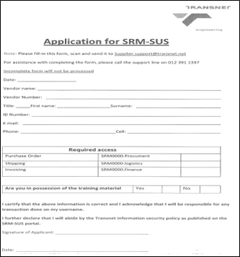
- This form is available from the TE support team or the portal. Email them on Supplier.Support@transnet.net
REQUIREMENTS
To have access to SRM the following is required:
          - X1 Central email which will be used by the system to send all notifications.
          - Forms for user access who will transaction on the system.

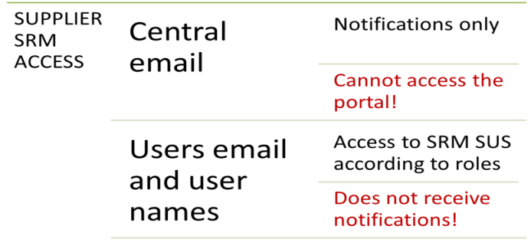
Click on Logon button to continue.

Login on to SRM SUS
Overview
This chapter will cover all the areas of accessing the SRM SUS Portal for suppliers.

PROCEDURE
To access the TE SRM SUS Portal you need to have access to the internet, and can only utilise the Internet Explorer browser. The following versions are supported:

- Browser 6 and 7 fully is supported; and
- Browser 8 and 9 is supported in compatibility mode

Warning
Please note that other browsers like Safari, Google Chrome, Firefox etc. are not supported and if used, may not load all the forms as required.
Transnet Engineering can only support users working in the recommended browsers.

Access the SRM SUS Portal transaction using the following navigation option:
- Click on your Internet Explorer icon on your computer

- Enter the URL : https://supplier.transnet.net/irj/portal
- The SRM SUS Logon screen is displayed
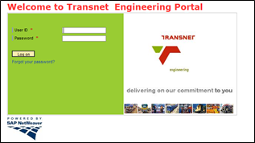
To logon follow the instructions:
Activity/Field Name | Data Input | Description
User ID | Enter user ID, E.g. 505415_001 | Enter your logon user ID as supplied to you by TE. This will start with your vendor number, underscore and 3 numbers
Password | Enter your password | Enter your unique password.
Click on Logon button to continue.
- The SRM SUS Landing Page screen is displayed and discussed in detail later in the learner guide.
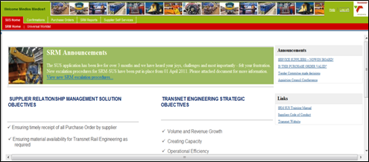

Resetting your Password
Overview
The Portal allows for resetting of forgotten passwords. This will reduce your waiting time for all calls logged through the TE helpdesk. Start the transaction using the menu path or the URL link above.

PROCEDURE
Ensure that you are accessing the correct browser to see all the functionality.
Access the SRM SUS Portal transaction using the following navigation option:
- Click on your Internet Explorer icon on your computer

- Enter the URL : https://supplier.transnet.net/irj/portal
- The SRM SUS Logon screen is displayed
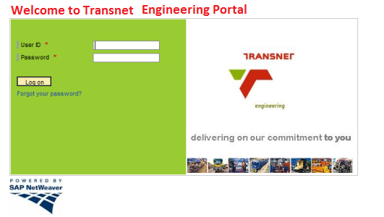
Click on “Forgot your password?” to reset your password

- Note: The SRM Login Assistant screen is displayed
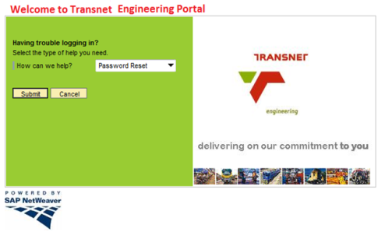

Activity/Field Name | Data Input | Description
How can we help? | Drop down list, select Password Reset | Select password reset from the drop down

Click on Submit to continue.
- Note: The Password Reset Information screen will be displayed
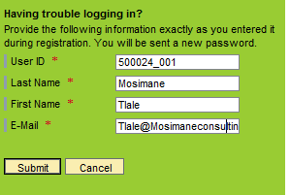

Activity/Field Name | Data Input | Description
User ID | Enter user ID, E.g. 500024_001 | Enter your logon user ID as supplied to you by TE. This will start with your vendor number, underscore and 3 numbers
Last Name | Enter your last name | Enter your last name
First Name | Enter your first name | Enter your first name
Email | Enter your user email address | Enter your user email address, not the group email. This is the email that will be used to send your new password.  The system will validate this email with the email TE has on the system. You cannot enter a different email address.
Click on Submit to continue.
The message will be displayed and you will be routed back to the logon screen.
An email will be sent to your email from TE Portal.
Once you have received your new password via email you may logon again using the logon instructions above.
- Caution: The system will indicate that your password has expired as it is a system generated password. You will immediately be required to reset your password.
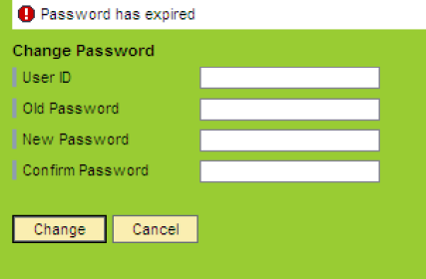
Activity/Field Name | Data Input | Description
User ID | Enter user ID, E.g. 500024_001 | Enter your logon user ID as supplier to you by TE. This will start with your vendor number, underscore and 3 numbers
Old Password | Enter the old password | Enter the password form the email received
New Password | Enter your new password | Enter your new password
Confirm Password | Enter your new password | Enter your new password again as confirmation
Click on Change 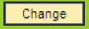 to continue.

- The SRM SUS Landing Page screen. This will be discussed in detail below.
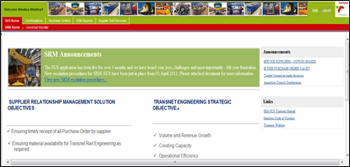

Browsing the SRM SUS Portal
Overview
Once you have successfully logged onto the SRM SUS portal, you will be able to navigate and transact in the application.

PROCEDURE
Follow the logon instructions above.
- You are now on the SRM SUS Landing Page.
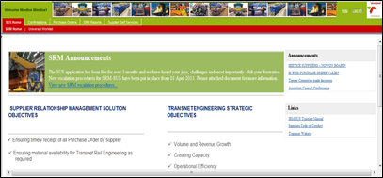
- This page displays all the news and views, as well as important communication for suppliers.
- Links to electronic manuals can also be located on this page.
- Always browse around to see if there is anything important you need to know.
Click on the Supplier Self Service button to continue.

If there are any certificated errors the following message might be displayed:
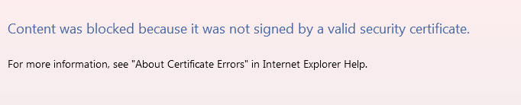
At the bottom of the screen the blocked message will be displayed.
Click on the Show content 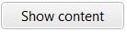 button to continue.
Notes
Please note that the SRM SUS portal uses a secured bandwidth line and is safe for all suppliers to use.
- The Supplier Self Service Page screen is displayed.
Tips
The RED highlight indicates the page you are on. On this page we are looking at the Supplier Self Service Page and its related content – this red highlight indicated this.
All areas within the Supplier Self Service Page will also be highlighted.
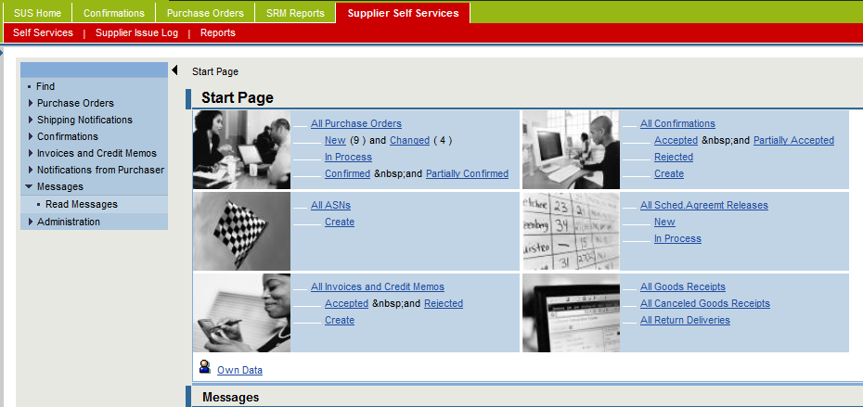
The following tabs are available:
Self-Services - | All the functions within self-services are located within this tab. This includes Purchase Order functionality, Advanced Shipping Notification functionality, Shipping Document functionality, Service Entry Sheet functionality, In-plant delivery (ASN Scanning) functionality, Invoice functionality as well as Non Conformance Reporting functionality.
Supplier Issue Log - | A supplier can log an issue directly from SRM on this tab.
Reports - | All SRM SUS reporting is located on this tab.

Understanding the screen layout
The SRM SUS screen has two areas – the menu tree and the working area.
- The menu tree is on the left hand side of the screen:
Item | Description
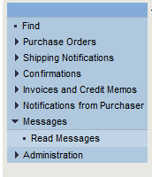 | The menu tree groups all related functionality.  - When it is expanded it will show an icon with a dot next to the menu item -  - When it is collapsed it will show a right facing arrow indicating that there is data hidden -  - An expanded menu item with other items within it will show a downward facing arrow -

Notes
The start page will display similar data in a different format only at the main landing screen or start page.
Once an item is selected – this turns into the transactional working area.

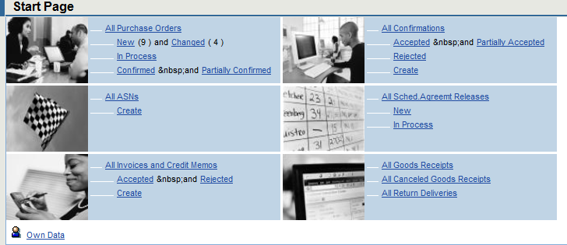
- The working area is on the right hand side of the screen:
Description | Item
The start page responds to selected menu items.  - As the menu items on the right change or the start page is used to select functions, the working area will change accordingly. | 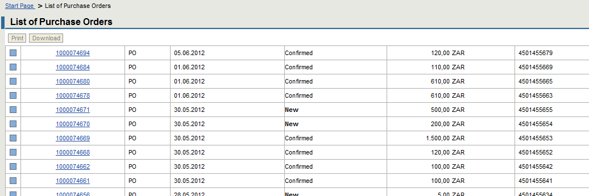

Changing your own data
Overview
Users will be able to change their own data.
Click on the Own Data tab to access this functionality.
Data that can be changed is:
- Name and Surname
- Telephone Number
- Fax Number
- Email address
- Department
- Reset own password

PROCEDURE
Follow the logon instructions above until you are on the Self Service screen.

- The Supplier Self Service Page screen is displayed.

You can access the Own Data from the menu tree and the working area.
If using the menu tree follow these instructions:
Click on Administration on the menu tree. This will expand the menu item; and
Click on Own Data on the menu tree.

If using the Start Page follow these instructions:
Click on the Own Data button on the working area.

- The Own Data screen is displayed.
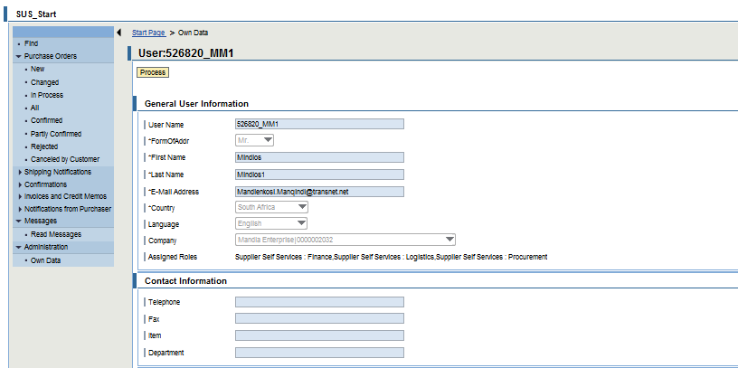
- Note: You are on the display screen for user information.
Click on the Process button to make the desired changes.
- The change Own Data screen is displayed.
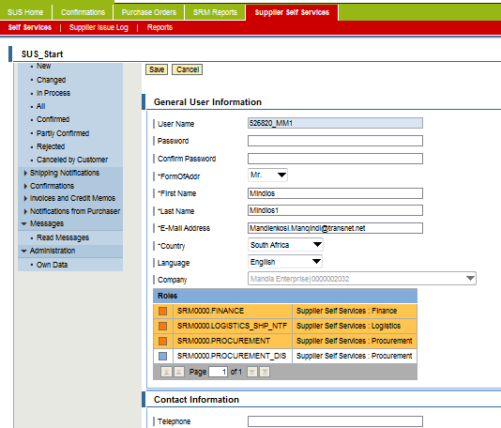
- This page displays all the user related data. Not all the information. Users can edit only open field.
- The roles (authorisation access) allocated to the use are displayed on this page.
- The user password can also be changed on this page.
You are now able to make the required changes.
Click on the Save button to continue and save your changes
- Note: You will be taken back to the display screen for user information.
In a Nutshell
The SRM SUS screen is a simple internet based screen. Users are able to manage their own data and navigate the application from both the work area and menu tree.
Looking Forward
The next chapters will take you through the functionality of the SRM SUS application from Purchase Order to Payment stage.
Not all suppliers will use all the functionality, for instance service suppliers may not use ASN or shipping functionality. The learner guide contains all the functionality and the supplier needs to follow the relevant and related functions for their business.

Authorisation Access
The available access for suppliers is as follows:
Reference | Access Code | Functionality
Purchase Order | SRM0000. Procurement | - Accessing and managing PO’s
Shipping | SRM0000.Logistics | - Creating ASN’s and Shipping Documents  - Printing shipping documents  - Managing all shipping functions
Services | SRM0000.SES_SUS | - Creating a Service Confirmation  - Managing all service related functions
Invoicing | SRM0000.Finance | - Creating Invoices, Statements and Credit Memos  - Managing all finance related functions  - Printing Remittance Advices
Non Conformance Reporting | SRM0000.NCR | - Accessing NCR’s  - Responding to NCR’s
Make sure that you allocate the correct access to your organisational representatives.

Notes
TE has created an additional measure internally to control role allocation. Where one does not have a role to create an invoice, or an ASN, or a Service confirmation – this button will not be made available on the screen for ability to execute this function.

Managing Supplier Emails
The SRM SUS portal requires one email address for ALL notifications. This is what we call the group or central email address.

Should this email be incorrect or change – it is the SUPPLIER’S responsibility to inform TE of the changes.
Failure to send the updated group email address will result in the following:
- No communication from TE
- No notifications of new or amended PO’s, NCR’s, Invoices, Invoice Statement or Service Confirmations
Warning
Remember, TE does not send emails to individual users email addresses. The group or central email is the single most important email for the SRM SUS portal.

PURCHASE ORDER MANAGEMENT PROCESS
Course map
This course consists of the following chapters:
 | Chapter | Description
 | 1 | Login on, Passwords and Authorisation Access
 | 2 | Purchase Order Management
 | 3 | Advanced Shipping Notification and Shipping Document
 | 4 | Pre-Receipt Process
 | 5 | Service Confirmation
 | 6 | Supplier Non Conformance Management
 | 7 | Finance – Invoice and Invoice Statement Submission
 | 8 | BBBEE and Tax Clearance Certificates Upload
 | 9 | Tracking and Reporting
 | 10 | SRM SUS Call Log and Support
Learning Outcomes
- Receiving a Purchase Order from TE
- Changing a Purchase Order and sending to TE
- Accepting a Purchase Order and sending to TE
Overview
This chapter will cover the purchasing process, and all aspects related to managing a Purchase Order. This process relates to both service and material suppliers.

Process Flow
The Process flow below indicates the detailed PO process as implemented in TE.
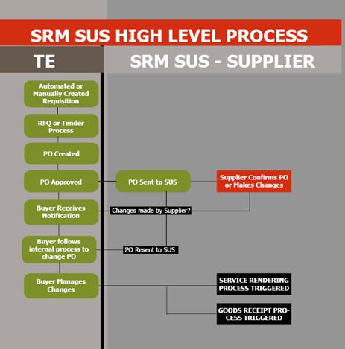

Receiving a Purchase Order from TE
Overview
All material and service suppliers have to receive a valid PO from TE through the portal to initiate all activities within the application.
Follow on activities are always linked to a PO and without a transmitted SUS PO, the application cannot be used.
ALL SRM SUS suppliers should refrain from requesting emailed PO’s from the supplier as all subsequent SRM SUS functionality is disabled if this process is not initiated and follow on functions are not actioned properly.
The process below indicates the step by step tasks and activities for the SRM SUS Purchasing or Purchase Order process.

Tips
There are two ways on which the supplier will be informed if there is a new Purchase Order or Changed Purchase Order, namely :-
- An Email Notification will be sent to Supplier’s Group Email Address(please note: this is not the user email address), or
- By logging onto the SRM-SUS Portal and checking for any new Purchase Orders.

PROCEDURE
Follow the logon instructions above once the notification has been sent to the group email address or to check for new Purchase Orders.

- You are now on the SRM SUS Landing screen

Notes
This process will be performed by the vendor user to either confirm or reject the entire Purchase Order Lines; however, the user can still partially confirm and reject some Purchase Order Lines.

- Tip: There should a “New” or “Changed” Purchase Order Number replicated into the Portal.
- Caution: It is recommended that you respond to all the Purchase Order Lines.
Using the Work Space or the Menu Tree, the instructions are similar. These instructions below use the work space.

New Purchase Orders

PROCEDURE
Under All Purchase Orders
Click on the new icon to view all new Purchase orders
Tips
The number of new Purchase Orders will be indicated by a number next to the New icon.
If there are no new PO’s, there will be no number.
- You are now on the List of New Purchase Order screen
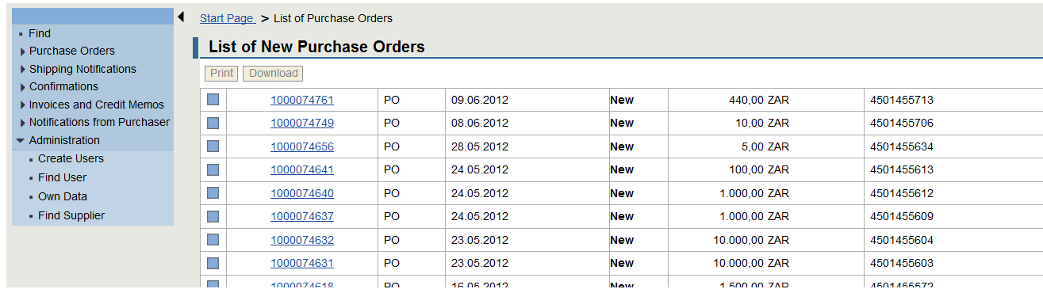
Click on the Purchase Order line item you would like to display. This will have the SRM SUS document number with a prefix 10*.
Notes
There are 2 numbers on the SRM SUS PO.
- Document Number starting with 10* is the system number range. This is a unique SRM SUS number that is not visible to the rest of Transnet Engineering,
- Transnet Engineering Purchase Order starts with 45* number range. Internal TE employees will only be able to see and assist you with the number that starts with the 45*
- To view the TE PO number you need to access the order through the document number. The PO number is under the basic data information.

- You are now on the Display Purchase Order screen
The message screen is hidden until there are Purchase Order messages. This will normally be placed at the top of the screen and will show errors and information relating to the transaction being actioned.
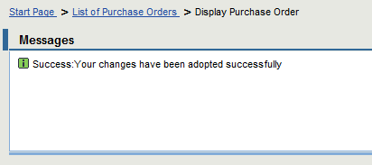
- The basic data information is displayed at the top
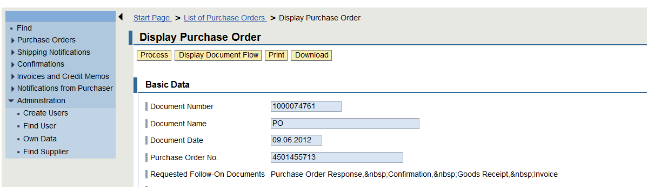
- The item overview information is displayed next on the screen.
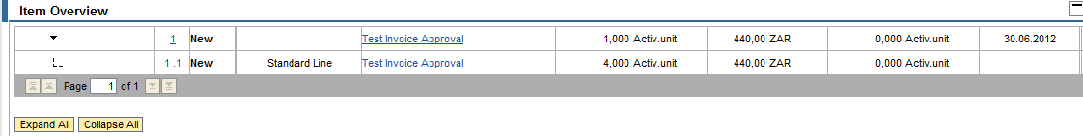
Notes
For all service purchase Orders, 2 lines will be displayed per line item, for example 1 and 1.1, 2 and 2.1 etc. These additional lines are called service line items.
For goods only one line item will be displayed

- The message information is displayed next on the screen
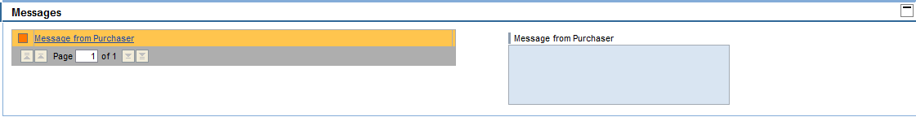
Notes
The message screen will display any information from the Procurement Official.
When processing the PO, this is where any messages for the Procurement Official will also be entered in this area.
- The Partner and Price information is displayed next on the screen
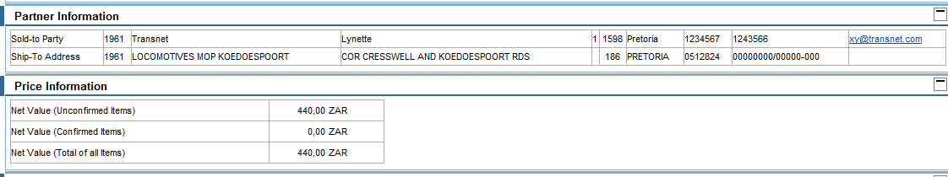
Notes
The partner information screen will display information related to the delivery addresses. These are critical to all suppliers as goods and services must be delivered to the PO specified delivery address.
The price information indicates the total PO price.
- The Terms of Payment and Delivery information is displayed next on the screen. TE normally pays 30 calendar days (per month) from invoice receipt.
- The Attachments information is displayed next on the screen. Any attachments from the Procurement Official will be displayed in this area.
- Caution: You are on the display screen and cannot make any changes.
Click on the Process button to make changes to the Purchase Order
- You are now on the Process Purchase Order screen
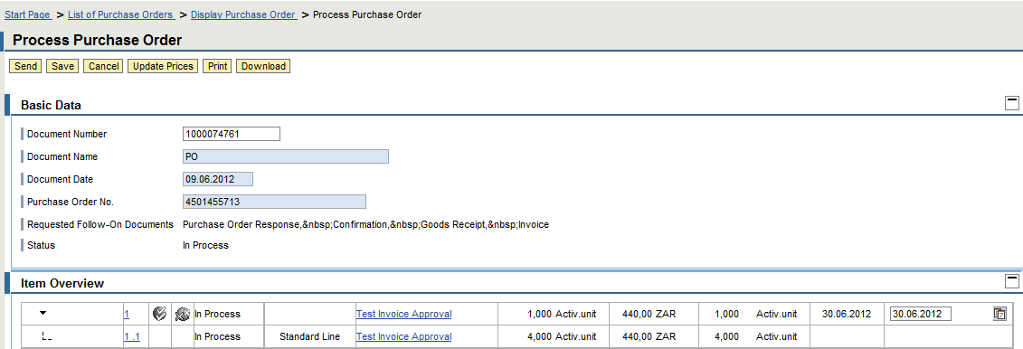
- On the process screen, you will be able to either accept/reject the Purchase Order Lines.
- You can only make change recommendation to quantities and dates.
- You can send the Procurement Official a message on this screen.
- Note: The document status is now in process.

Confirming your Purchase Order
Notes
All items in the PO can be confirmed collectively or each item can be confirmed individually.

PROCEDURE
Click on the Confirm All Items button. In this case you agree to deliver as per the PO as it is without making any changes.
- Caution: To accept individually the icon below is used.
Click on the Confirm Item button.
Click on accept terms and conditions 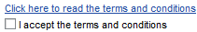check box.
- If Terms and Condition are not accepted, the Purchase Order response will not be successful.
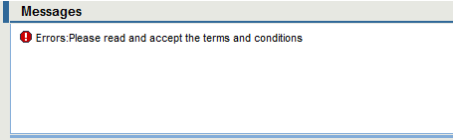
Click on Save to continue and adopt the changes.
Notes
You can exit SRM SUS and return back to complete this item at a later stage. It is recommended that you keep on saving your work as you may from time to time loose your internet connection or be timed out if you are busy with other work.
Click the Send icon to send the PO confirmation to TRE.
The message is displayed.
This message indicates that your changes have been successfuly adopted and sent to TE.
Notes
This means that your PO confirmation has been sent to Transnet Engineering and a notificaiton is sent to your Procurement Officer to indicate your confrimation of the PO and any changes made on it.
Click the List of Purchase Order item to process the next item.
Notes
When returning back to the list of Purchase Orders, all PO’s that have been sent would have been removed. All PO’s that have saved will still remain.
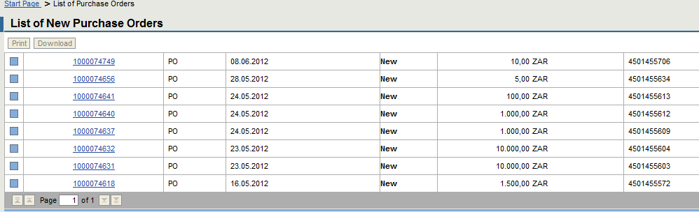
OR
Click the Start item to access a different function.
Notes
When returning back to the Start page, the Purchase Order count would have been updated with the processed PO removed.
E.g. From to
OR
Click the Log off item to exit TE’s SRM SUS application.
Tips
To reject the items lines or the entire PO, then click on the reject buttons as per the instruction below.

Rejecting your Purchase Order
Notes
All items in the PO can be rejected collectively or each item can be rejected individually.

PROCEDURE
Click on the Reject All Items button. In this case you do not agree to the entire PO.
- Caution: To reject individually the icon below is used.
Click on the Reject Item button.
Enter a message to the Procurement Official stating your reason for rejection.
Click on the message to purchasericon. The message text screen will be enabled
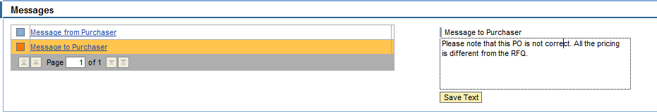
Item | Description
Message to Purchase | Enter a detailed message to purchase about the rejection of the line(s) of the PO.
- Tip: Always ensure that you write a precise message to the buyer to indicate reasons for rejection and any other relevant information to ensure that the PO is corrected and resubmitted.
Click on Save Text to continue and adopt the changes.
Click on accept terms and conditions check box.
- If Terms and Condition are not accepted, the Purchase Order response will not be successful.
Click the Save button to save your changes.
Click the Send icon to send the PO rejection to TE.
The message is displayed.
This message indicates that your changes have been successfuly adopted and sent to TE.
Notes
This means that your PO rejection has been sent to Transnet Engineering and a notificaiton is sent to your Procurement Officer to indicate your confrimation of the PO and any changes made on it.

Caution
Every rejected PO will be reviewed by TE and resubmitted to SRM SUS. When it is resubmitted it will be placed under Changed PO and not New PO.

Changed Purchase Orders

PROCEDURE
Under All Purchase Orders
Click on the Changed button to view all changed Purchase orders
Tips
The number of changed Purchase Orders will be indicated by a number next to the Changed icon.
If there are no changed PO’s, there will be no number.

Notes
Changed Purchase Orders are those that have been actioned by the user (accepted or rejected) and returned to the portal after changes made by Transnet Engineering
In Process orders are those that have been accessed by the user and not yet transmitted to TE (accepted or rejected).
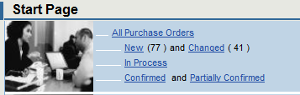
- You are now on the List of New Purchase Order screen
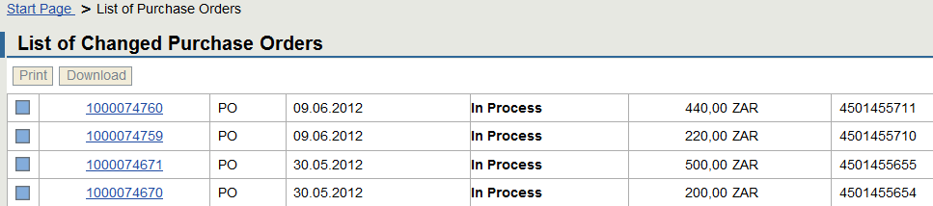
Click on the Purchase Order line item you would like to display
Notes
For changed Purchase Orders, the status will be In Process -
- You are now on the Display Purchase Order screen
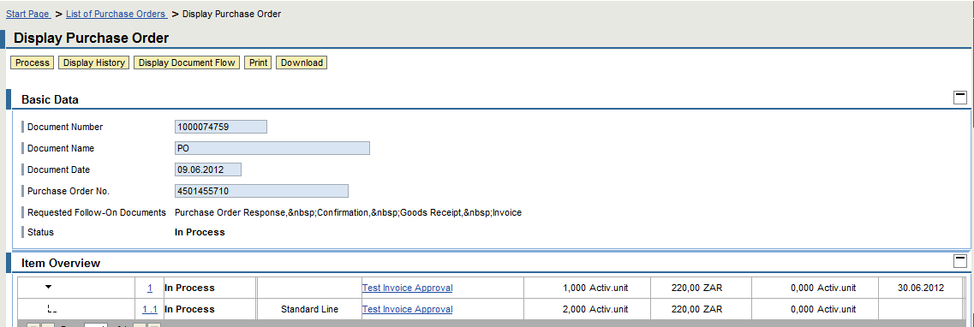
- Caution: You are on the display screen and cannot make any changes.
Click on the Process button to make changes to the Purchase Order

- You are now on the Process Purchase Order screen
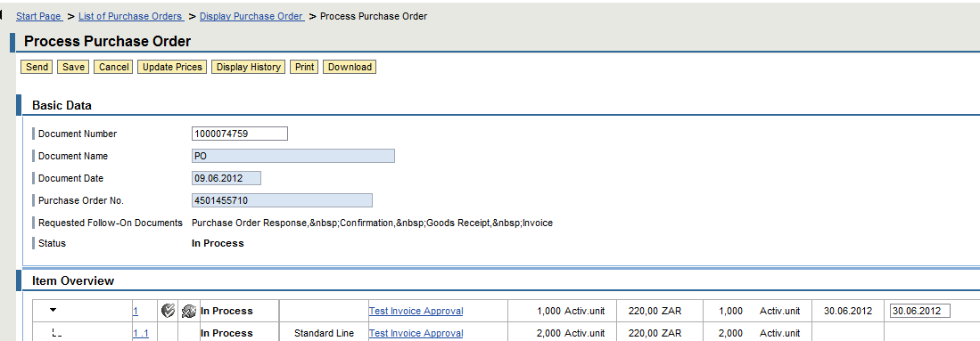
- On the process screen, you will be able to either accept/reject the Purchase Order Lines.
- You can only make change recommendation to quantities and dates.
Continue to make changes, confirm or reject lines as per the instructions under new Purchase Orders.

Making Changes to Purchase Orders

PROCEDURE
Under All or Changed Purchase Orders
Click on the New or changed button to view all new Purchase orders
- You will be on the List of New or Changed Purchase Order screen
Click on the Purchase Order line item you would like to display. This will have the SRM SUS document number with a prefix 10*.
Click on the Process button to make changes to the Purchase Order
- You will be on the Process Purchase Order screen
Warning
You can only make changes to delivery dates or quantities.
All scheduled deliveries must be managed as per the next chapter without changing the PO quantities.

TO MAKE CHANGES TO THE DELIVERY DATES
- Each line item has its own date therefore to change dates you need to change dates per line item.
Click on the Calendar icon to make recommendations for a new date. The date calendar will pop up.
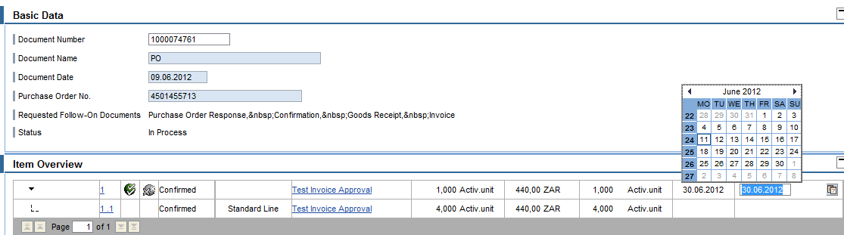
Item | Descriptions
Date | Enter or select recommended date from the drop down
Ensure that you reject all line items where changes have been made and a message is entered for the Procurement Official for the changes and rejection.
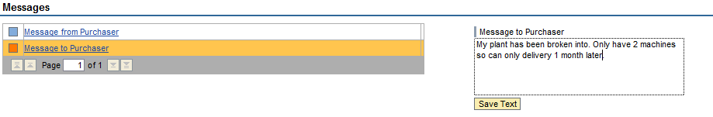
TO MAKE CHAGES TO QUANTITIES
If changes are made to the quantities, the order must still be amended from the TE side therefore it is recommended that once the quantity changes are made, the order is still rejected with notes to the Procurement Officer.

Making changes to quantity and dates
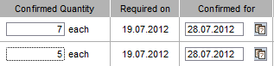
Updating your messaging updates the messaging
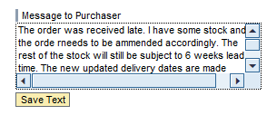

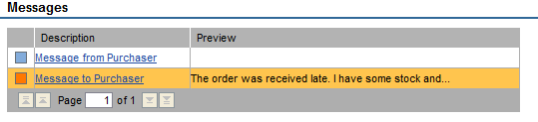
Click on the update pricing tab to continue
The system will update pricing and the following:
- Order quantity versus confirmed quantity
- Required date versus confirmed date
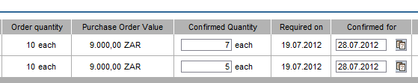

TO COMPLETE YOUR TRANSACTION
Click on accept terms and conditions check box.
Click the Save button to save your changes.
The messages area indicates the status of the PO.
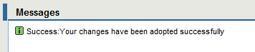
Click the Send icon to send the PO confirmation to TE.
The message is displayed.
This message indicates that your changes have been successfuly adopted and sent to TE.
Notes
This means that your PO confirmation or rejection has been sent to Transnet Engineering and a notificaiton is sent to your Procurement Officer to indicate your confrimation of the PO and any changes made on it.

Creating Scheduled Deliveries
Tips
Scheduled lines are created where scheduled delivery will take place by the supplier. In the case where TE has created a PO with the quantity for all the material being procured, as a supplier you are able to create scheduled lines for a scheduled delivery or part deliveries.
All scheduled delivery quantities must equal to the total PO total line quantity.
- This can be done for projects where payment will be over a period of months as goods delivery is over a period of months.
- This can be done for services where payment will be over a period of months where service delivery is over a period of months.

Click on the New or Changed button to view all new or changed Purchase orders respectively.
- You will be on the List of New Purchase Order screen
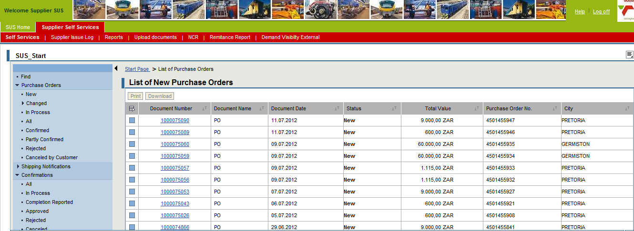
Click on the Purchase Order line item you would like to display.

- You will be on the Display Purchase Order screen
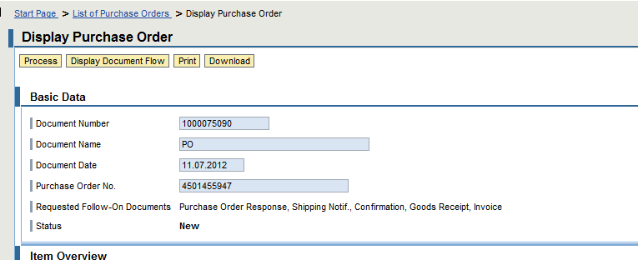
Click on the Process button to make changes to the Purchase Order
- You will be on the Process Purchase Order screen
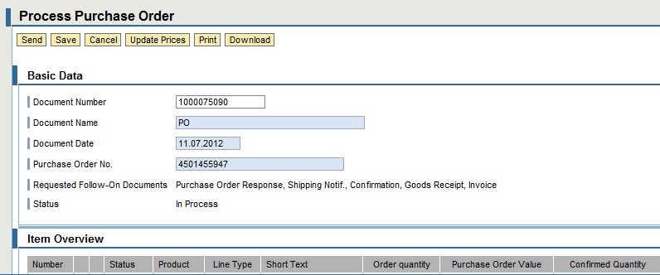
Click on the item number you want to create schedule deliveries for, e.g. item 10.
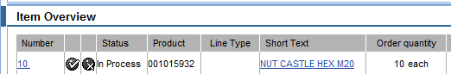
- Note: The Delivery Lines screen will appear below the item overview section
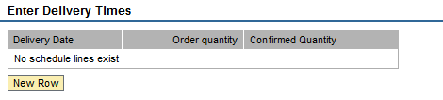
Click on New Row button to enter quantities and dates.
- You are now on the Enter Delivery Times screen
Enter your delivery schedule with dates and quantities to be delivered. You can enter multiple rows until your confirmed quantity is complete.
- Caution: Remember your delivery schedule when creating your ASN.
- Once the complete ASN quantity is created, one cannot create another ASN for that PO.
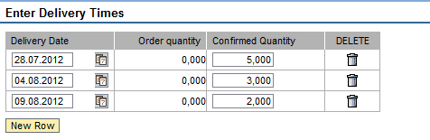
Click on the back to item overview tab to continue when complete with schedule lines creation.
- Tip: Notice that your line item has a new icon for phased deliveries - 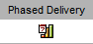. When you click on this you will be able to view your entered data.
Click on the Confirm Item button.
Click on accept terms and conditions check box.
Click on Save to continue and adopt the changes.
Click the Send icon to send the PO confirmation to TE.
The message is displayed.
This message indicates that your changes have been successfuly adopted and sent to TE.
Notes
This means that your PO confirmation has been sent to Transnet Engineering and a notificaiton is sent to your Procurement Officer to indicate your confrimation of the PO and any changes made on it.

Printing your Purchase Order
Overview

PROCEDURE
Purchase Orders can be printed from SRM SUS.
- Navigate your way to the Process Purchase Order screen
Click the Print button to view your PO in a printable format.

Your will receive a pop up screen similar to the one below:
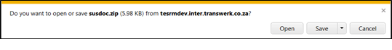
Click the Open 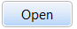 button to open the Purchase Order.

Your will receive a pop up screen similar to the one below:
Click the Open button to open the PO.
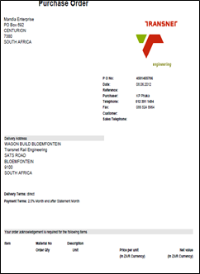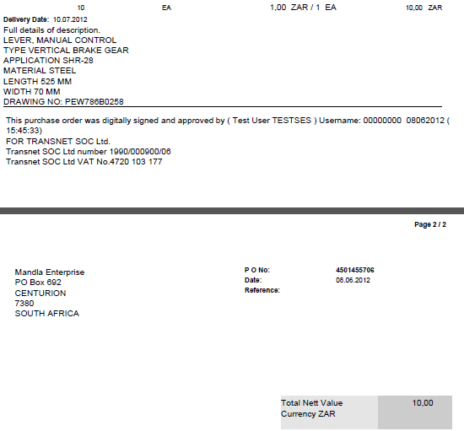
The PO is displayed on PDF and can be printed to your local printer.
- Caution: The SRM SUS PO will always be displayed or saved in PDF and it is electronically signed.
Should you select the Save 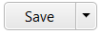 option, the standard microsoft saving options are presented. 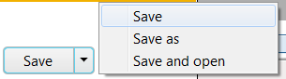.
- Your PO can be saved to a relevant location for future use.

ADVANCED SHIPPING NOTIFICATION AND SHIPPING DOCUMENT
Course map
This course consists of the following chapters:
 | Chapter | Description
 | 1 | Login on and Passwords
 | 2 | Purchase Order Management
 | 3 | Advanced Shipping Notification and Shipping Document
 | 4 | Pre-Receipt Process
 | 5 | Service Confirmation
 | 6 | Supplier Non Conformance Management
 | 7 | Finance – Invoice and Invoice Statement Submission
 | 8 | BBBEE and Tax Clearance Certificates Upload
 | 9 | Tracking and Reporting
 | 10 | SRM SUS Call Log and Support
Learning Outcomes
- Creating an ASN
- Creating a Shipping Document
- Printing an ASN and Shipping Document

Overview
This chapter will cover the creation of an Advanced Shipping Notification (ASN) or Shipping document for goods prior to delivery to Transnet Engineering.

Process Flow
The Process flow below indicates the detailed ASN process as implemented in TE.
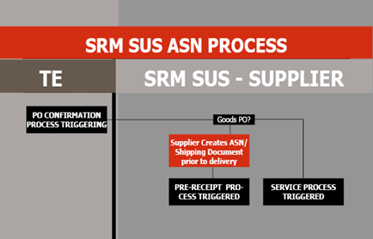

Creating an Advanced Shipping Notification (ASN)
Overview
An ASN will be created when a supplier is ready to deliver their goods. ASN acts a confirmation that the ordered materials will be delivered based on the ASN Delivery date.
Notes
ASN’s and Shipping Documents are only applicable for goods.
Services will follow a different process

PROCEDURE
Follow the logon instructions in chapter 1.
- Navigate the screen until the Supplier Self Service Page screen is displayed.
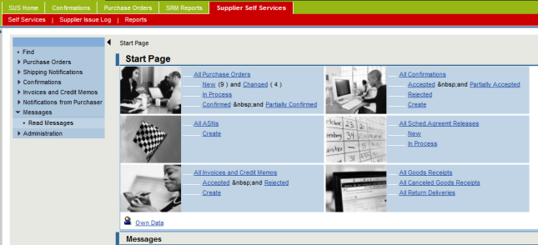
- Note: You may use the Menu Tree or Work Area. The Instructions below use the Work Area.
Click the Create ASN icon under All ASN’s.
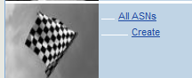
- You are now on the List of Purchase Orders screen
Warning
This area will only display those PO’s that have been confirmed and are ready for delivery.
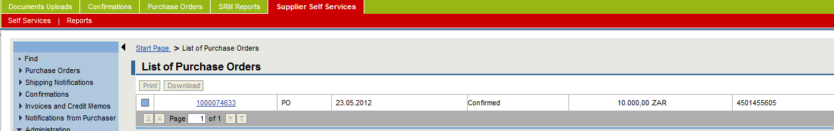
Click the item number you would like to process and create an ASN for.
- You are now on the List of Purchase Orders screen
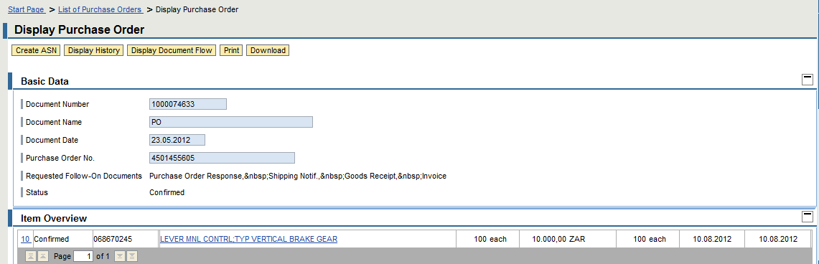

Notes
The icon for the ASN will be displayed for all PO’s ready for ASNs or Shipping documents. If any PO lines were rejected at PO processing stage, these will not be available for ASN creation until they are confirmed.
All Service Purchase Orders will not have a Create ASN button visible.
Click the Create ASN you would like to process and create an ASN for.
- You are now on the Process ASN screen
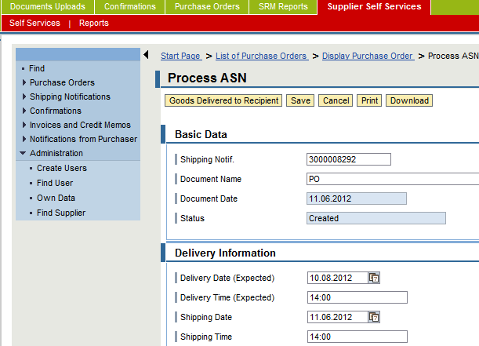
Notes
Under Basic Data new document number is created with a prefix 30*. This is your ASN number which will be displayed on the TE application side as well, and is automatically linked to your purchase Order.
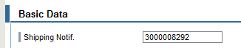
Enter the following information:
Item | Data Input | Description
Delivery Date (Expected) | Enter date, e.g. 10.08.2012 | Enter the date the goods will be delivered
Delivery Time (Expected) | Enter time, e.g. 14:00 | Estimate the delivery time (does not have to be exact)
Shipping Date (Expected) | Enter date, e.g. 10.06.2012 | Enter the date the goods will be shipped on
Shipping Time (Expected) | Enter time, e.g. 14:00 | Estimate the shipping time (does not have to be exact)
Means of Transport | e.g. Truck | Select means of transport from drop down
Transport ID code | e.g. Truck BD BDB BD GP | Enter your unique transport code
Bill of Lading | Enter bill of lading | Enter your bill of lading
Click the Select All Items to select all for delivery.
- Caution: If you are not delivering all items, select only the line items that you are delivering and creating an ASN for.

Once all items to be delivered are selected, continue with the following instructions:
Click the Propose Outstanding Quantities for the delivery.
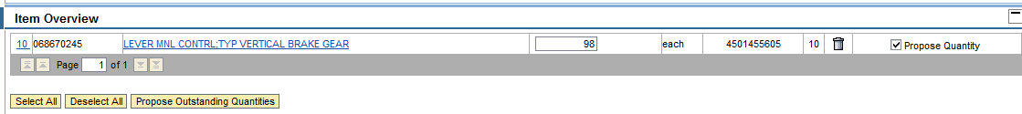
- The system will propose all outstanding quantities for each PO line.
- Should you wish to deliver less than the proposed quantities, and then make changes to the items you wish to change.
- Delete all lines in the PO that will not form part for your delivery, and as such your ASN.
Click the Goods Delivered to Recipient button.
- Caution: This serves as your save button.
The message is displayed. This message indicates that your changes have been successfuly adopted and sent to TE.
The PO is updated accordingly.

Notes
Your ASN number will have a 30* prefix, for example 3000008223

Printing your ASN
Follow the logon instructions in chapter 1.
- Navigate the screen until the Supplier Self Service Page screen is displayed.
- Note: You may use the Menu Tree or Work Area. The Instructions below use the Work Area.
Click the All ASNs icon under All ASN’s.
- You are now on the List of ASN’s screen

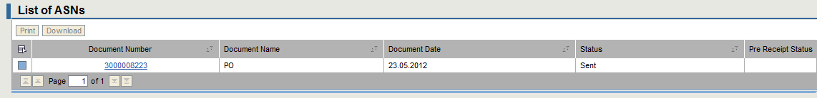
Click the ASN number you would like to print.
- Note: The Display ASN screen is displayed.
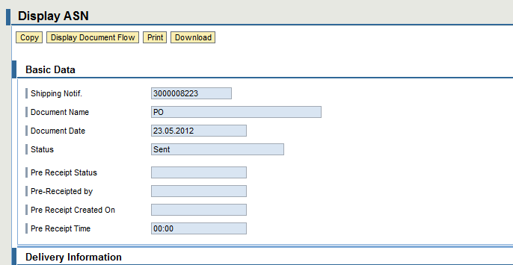
Click the Print button to print your ASN.
Your will receive a pop up screen similar to the one below:
Click the Open button to open the ASN.
You will receive a pop up screen similar to the one below:
Click the Open button to open the ASN.
Your zip program will commence to load the ASN.
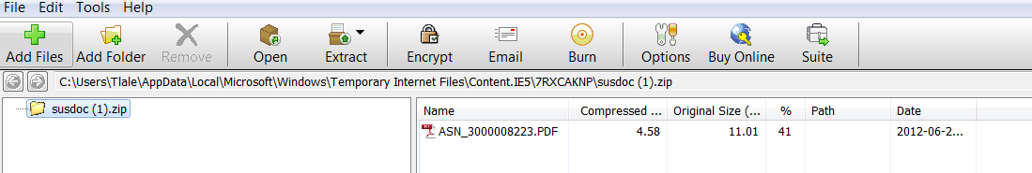
Double Click the ASN PDF icon to open the ASN.
- Note: The Shipping Document (ASN) document is displayed.
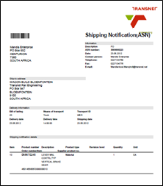
The ASN is displayed on PDF and can be printed to your local printer.
Should you select the Save option, the standard microsoft saving options are presented. .
- Your ASN can be saved to a relevant location for future use.
Notes
The ASN is a compulsory document for warehouse goods receipt and must always be printed to accompany your goods.

Creating a Shipping Document
Overview
A Shipping Document is a collection of a number of PO’s that will be shipped to the TE warehouse together.
In simple terms a shipping document is a number of grouped ASN’s.
PO related to an ASN is a 1 to one relationship.
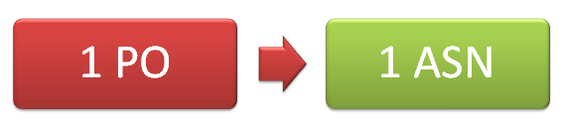
ASN related to a Shipping Document is a many to one relationship.
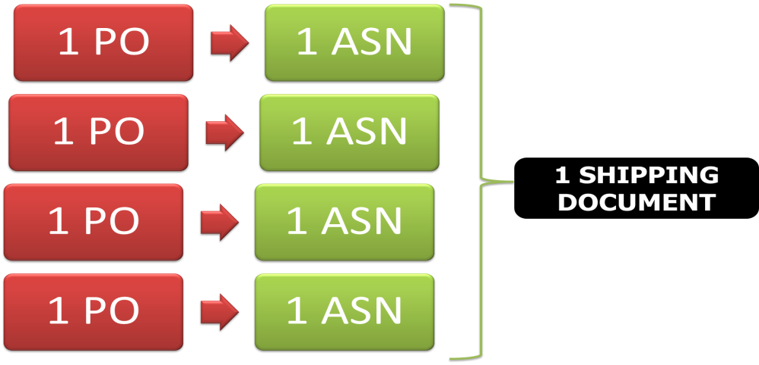

Shipping Document acts as a confirmation that the ordered materials will be delivered based on the Shipping Document Delivery date.
Notes
ASN’s and Shipping Documents are only applicable for goods.
Services will follow a different process

PROCEDURE
Follow the logon instructions in chapter 1.
- Navigate the screen until the Supplier Self Service Page screen is displayed.
- Note: You may use the Menu Tree or Work Area. The Instructions below use the Work Area.
Click the shipping documents icon
Notes
This will be at the header level of the screen.
- You are now on the Create A shipping Document screen
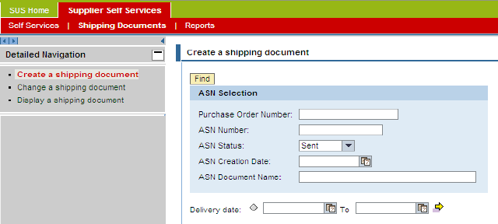
Click on the Create a shipping document menu item
- Tip: You can create the shipping document by using the ASN Selection search functionality.
You can search by PO, ASN number, ASN Status, ASN Creation ate and delivery date
- Caution: Make sure that the ASN Status is set to sent – you can only create a shipping document for created or existing ASN’s.
Click on the find button to start the search
- You are now on the Create A shipping Document screen for selection of relevant ASN’s
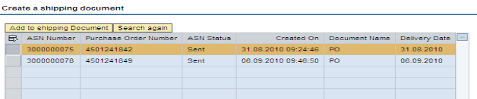
Click on the select all icon to select or deselect all the displayed ASN’s 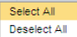
OR
Select the various lines you might want to add to document and click on the “Add to shipping document” button.
- You are now on the Create A shipping Document screen displaying a detailed view of your document
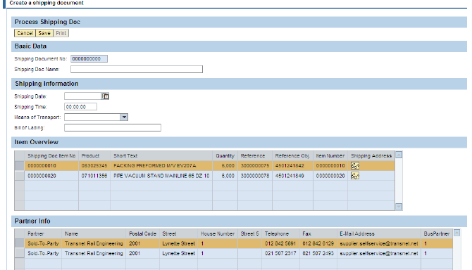
Enter the following information:
Item | Data Input | Description
Shipping Document Name | Enter name, e.g.  Koedoes Delivery – Loads” | Enter Shipping Document Name under basic data
Under Shipping Information data area, enter the following:
Shipping Date | e.g. 12.10.2012 | Enter shipping date
Shipping time | Enter estimated time | Enter shipping time
Means of Transport | e.g. Truck | Enter means of transport
Bill of Lading | Enter you bill of lading number | Enter you bill of lading number

Click on the save icon
- The Confirmation of creation message will appear with the unique Shipping Document Number
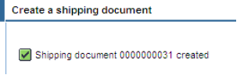
Click on the done icon
Click on the print icon to print your Shipping Document following the printing instructions from the ASN section.

Caution
The ASN or Shipping Documents are now COMPULSORY delivery documentation required by ALL TE WAREHOUSES to receive goods for SRM SUS suppliers.

Printing your Shipping Document
Click on the print icon to print your Shipping Document following the printing instructions from the ASN section.

Changing a Shipping Document

You can change you shipping document by clicking on the button and entering your shipping document number.
You can add or remove ASN’s prior to deliver.

ASN AND SHIPPING DOCUMENT PRE-RECEIPT PROCESS
Course map
This course consists of the following chapters:
 | Chapter | Description
 | 1 | Login on and Passwords
 | 2 | Purchase Order Management
 | 3 | Advanced Shipping Notification and Shipping Document
 | 4 | Pre-Receipt Process
 | 5 | Service Confirmation
 | 6 | Supplier Non Conformance Management
 | 7 | Finance – Invoice and Invoice Statement Submission
 | 8 | BBBEE and Tax Clearance Certificates Upload
 | 9 | Tracking and Reporting
 | 10 | SRM SUS Call Log and Support
Learning Outcomes
- Viewing the Pre-Receipt status for an ASN or Shipping Document
Overview
This chapter will cover the pre-receipt process for goods. The Pre-receipts will only be applicable at TE’s 6 main centre gates. The Pre-receipt is by no means a goods receipt and cannot be used to prove receipt of goods by the warehouse. The functionality has being implemented for control and information purpose for TE and our suppliers only.

Process Flow
The Process flow below indicates the detailed Pre Receipt process as iE.
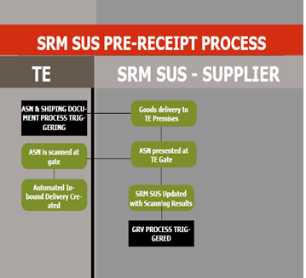

Display Pre-Receipt Status for your ASN
Warning
The Pre-Receipt status can only be updated for an ASN. Failure to accompany goods with an ASN means that the status will not be updated.

PROCEDURE
Follow the logon instructions in chapter 1.
- Navigate the screen until the Supplier Self Service Page screen is displayed.
- Note: You may use the Menu Tree or Work Area. The Instructions below use the Work Area.
Click the All ASNs icon under All ASN’s.

- You are now on the List of ASN’s screen
Click the ASN number you would like to print.
- Note: The Display ASN screen is displayed.
The Pre-Receipt informaiton is displayed in the Basic Data area of the Display ASN.
The followig information is made available once the scanning has been completed by the main gate security guard(s):
- Pre-Receipt Process
  - Red – there may be errors or issues with the PO, e.g. late deliveries, early deliveries ect which will surface at Good Receipt stage.
  - Green – the PO has no errors or issues and the Good Receipt will go smoothly.
Notes
The security guard will not make any decisions about the goods, regardless of the scanning results. The goods will still be routed to the warehouse.
- Pre-Receipt Security Guard ID
- Pre-Receipt Date
- Pre-Receipt Time
Caution
Blank information means that no Pre-Receipt (Scanning) has been completed.

When a pre-receipt has been completed, the ASN information will be displayed as below.
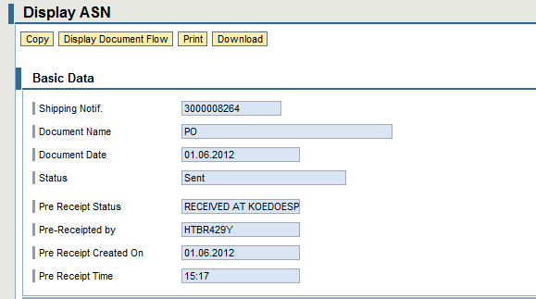

Notes
The pre-receript can only be done by scanning an ASN/Shipping document and it perfoms a number of important functions.
- It automatically creates an inbound delivery which is required for good receipt of all materials from a SUS vendor
- It updates the supplier with the centre and gate the goods have entered

Displaying a GRV
Once a Pre-receipt has been completed goods will be received in the warehouse.
Notes
Goods will be subject to quality assurance prior to GRV.
TE is committed to receiving all goods that have passed the quality inspection within 48 working hours of arrival at the warehouse

The GRV may initiate the NCR process or the Invoice process.
Notes
Where goods need to be returned to vendor, the goods will still be received, an NCR will be raised and sent to the vendor and the goods return will be completed with reference to the NCR.

PROCEDURE
Follow the logon instructions in chapter 1.
- Navigate the screen until the Supplier Self Service Page screen is displayed.
Click on the all goods receipt icon on the working area of the start page.
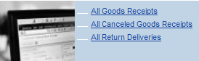
- Note: The Goods Receipt List screen is displayed
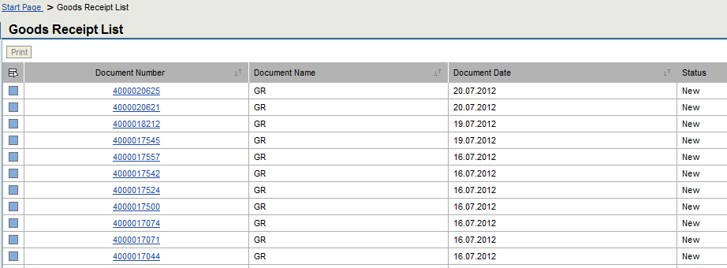
Click on the document number you would like to display.
- Note: You are not on the Goods Receipt List screen
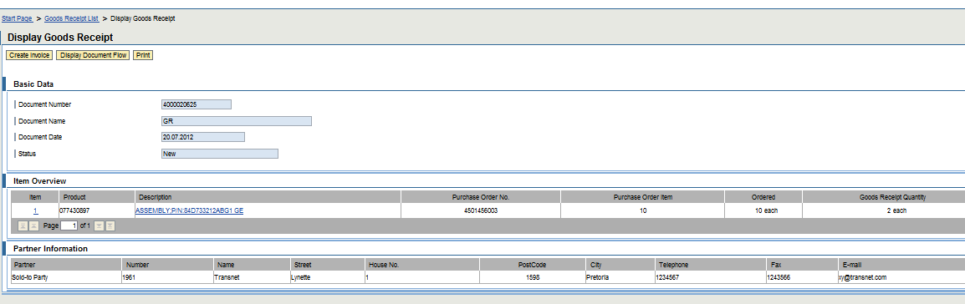
You can also display:
- All cancelled Goods Receipts by clicking on the relevant icon; and
- All return deliveries by clicking on the relevant icon.
Caution
SRM SUS will not allow suppliers to submit/upload an invoice until the GRV has been done on the system.

SERVICE CONFIRMATION
Course map
This course consists of the following chapters:
 | Chapter | Description
 | 1 | Login on, Passwords and Authorisation Access
 | 2 | Purchase Order Management
 | 3 | Advanced Shipping Notification and Shipping Document
 | 4 | Pre-Receipt Process
 | 5 | Service Confirmation
 | 6 | Supplier Non Conformance Management
 | 7 | Finance – Invoice and Invoice Statement Submission
 | 8 | BBBEE and Tax Clearance Certificates Upload
 | 9 | Tracking and Reporting
 | 10 | SRM SUS Call Log and Support
Learning Outcomes
- Creating a Service Confirmation for Services rendered
- Viewing Rejected Service Confirmations
Overview
This chapter will cover the Services process, submitting of a service entry sheet or confirmation, and managing rejection of confirmations from TE.

Process Flow
The Process flow below indicates the detailed Service Entry Sheet process or Service Confirmation process as implemented in TE.
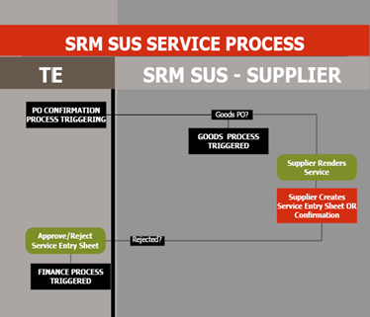

Create a Confirmation

PROCEDURE
Follow the logon instructions in chapter 1.
- Navigate the screen until the Supplier Self Service Page screen is displayed.
- Note: You may use the Menu Tree or Work Area. The Instructions below use the Work Area.
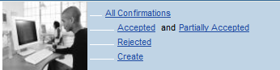
Click on the Create icon on the All Confirmation area of the start page.
- Note: The List of Purchase Orders screen

- Note: This list all your PO’s, including those that have been confirmed. Check the status of the PO for PO’s to confirm
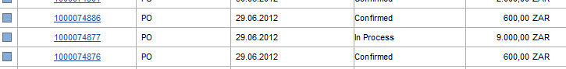
Warning
You cannot create a confirmation for a PO that is not confirmed or that has been rejected.

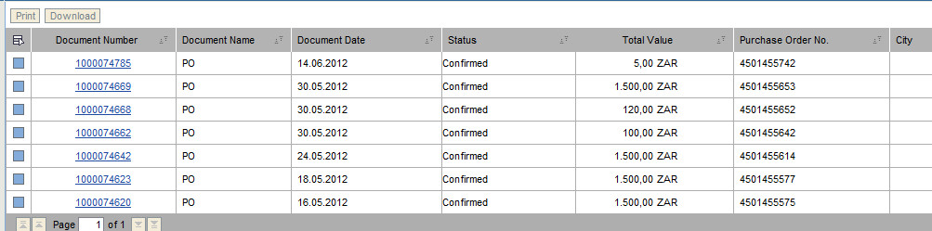
- Tip: The PO number is on the right of the screen for easy reference
Click on the Purchase Order Document Number you want to create a confirmation or service entry sheet for.
- Note: The Display Purchase Order screen is displayed.
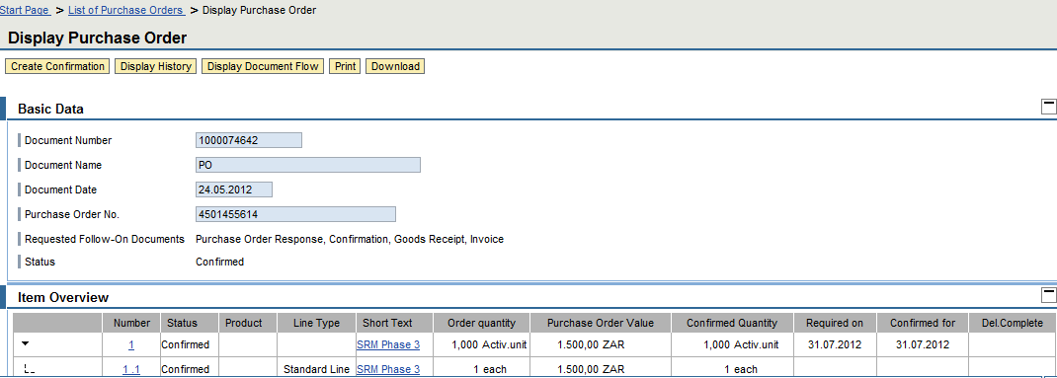

- Note: The Process Purchase Order screen is Displayed
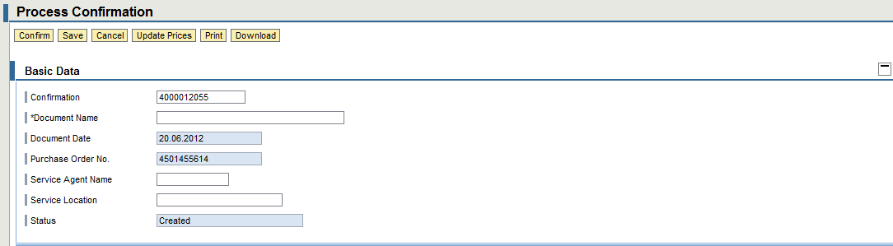

Click on the Confirm button to confirm the service rendered.
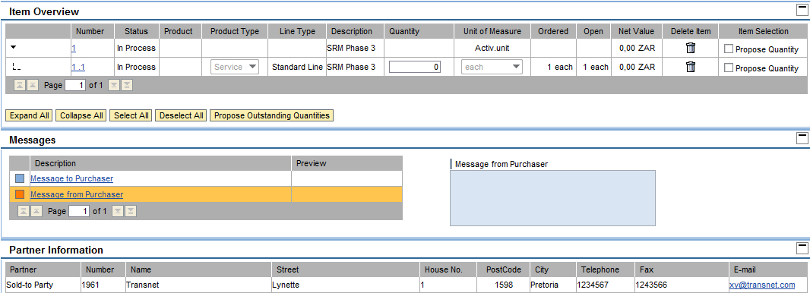
- Caution: Review your confirmation prior to creation to avoid a rejected confirmation from Transnet Engineering.
On the Basic Data area, enter the following information:
Item | Data Input | Description
Document Name | E.g. EXPERT GARDENS : July Services | Enter your service confirmation description.  Prefix your company name
Service Agent Name | e.g. Tlale Mosimane | Enter the service agent name
Service Location | e.g. Koedoespoort | Enter location where service was rendered
Once the basic data information is complete, continue to the item overview and the rest of the document.

Click on the Propose Quanity check box to pick up the Purchase order Quanities.

Item | Data Input | Description
Quantity | Enter the quantity for the service per service line

Notes
Remember to remove the service lines you may have not rendered yet but may form part of the PO.
Only include the service lines of those services rendered.

Click on the service lines to Delete, click on the delete icon.

Caution
Deleting the high live service line (parent level) will delete all the service lines. This means that the confirmation cannot be completed as there are no service lines to confirm.
Only delete the service line sub item levels (child level) of you are delivering in phases or part delivering the services.
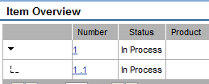
Child Level
Parent Level

- Tip: Notice how the parent level does not have any quanities to manage.
- All quanitties are lying at child level.
Click on the Message to Purchaser icon to add a messgae for the Procurement Official under the Messages tab.

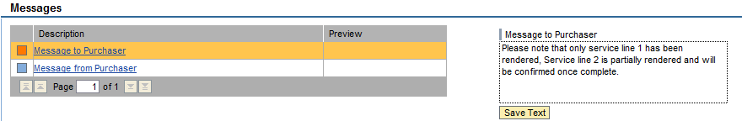
Click on Save Text to continue and adopt the changes.
Click the Save button to save your changes.
Click the Confirm button to send the confirmation to TRE.

- Caution: If the service delivery date is in the future, the system will still save and send the confirmation but will present a warning message.
The message 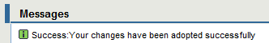is displayed. This message indicates that your changes have been successfuly adopted and sent to TE.This means that your Confirmation has has been sent to Transnet Engineering for approval or rejection.

Notes
The confirmation creates a Service Entry Sheet in the TE system. This is routed to the Budget Owner of the department where the service was rendered to approve.
This acts as a signature on the invoice previously required for services rendered to commence the finance process.

Viewing a Rejected Confirmation
When a service is accepted or rejected by TE, the portal will receive an update on the system to indicate the new status, in addition to the notification forwarded to the group email.
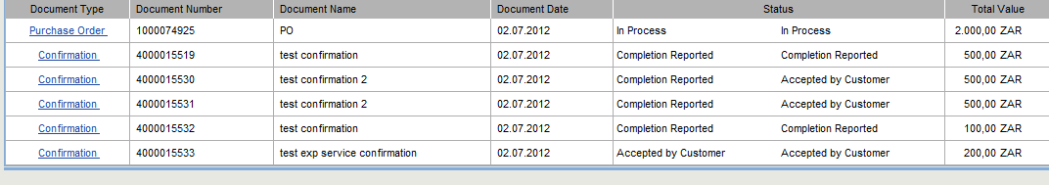
For Accepted Service Confirmations, the PO will be updated as per the screen below:
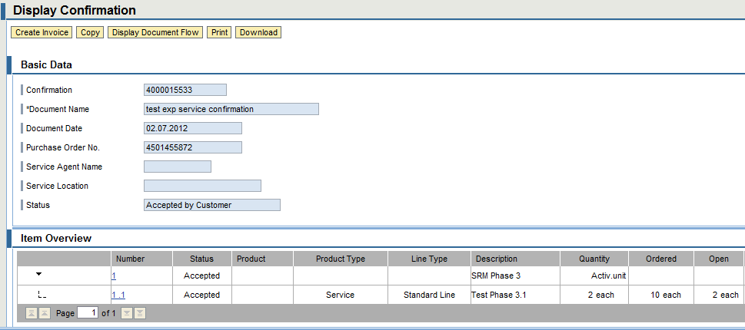
You will notice that when the confirmation is accepted, the supplier can now create an invoice.
The create invoice button is active. By clicking this, the finance portion of the process will commence.

For Rejected Service Confirmations, the PO will be updated as per the screen below:
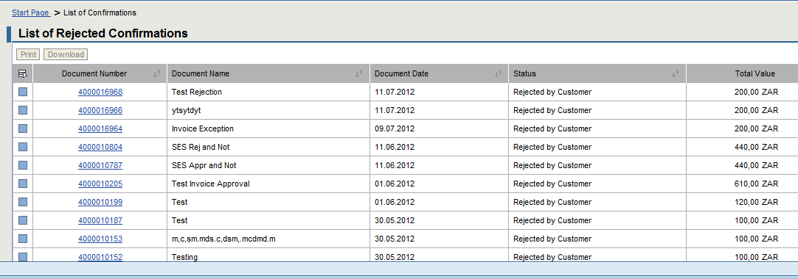

The reasons for rejection will be on the email notification sent to the central email address and not on the screen.

- Note: The Display Confirmation screen is displayed
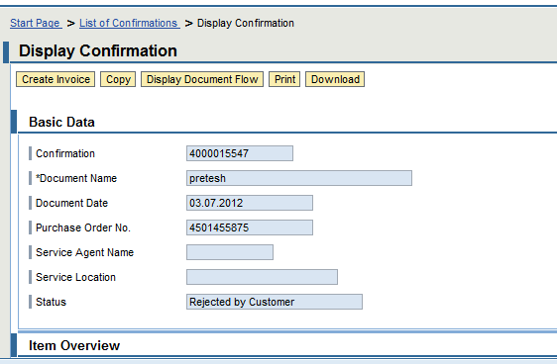
If one clicks on the create invoice button, the message below is displayed:
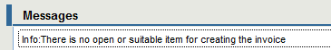
Warning
When a Service confirmation if rejected, it cannot be edited or “re-used”.
A new confirmation needs to be created for all rejected service confirmations.

SUPPLIER NON CONFORMANCE MANAGEMENT
Course map
This course consists of the following chapters:
 | Chapter | Description
 | 1 | Login on, Passwords and Authorisation Access
 | 2 | Purchase Order Management
 | 3 | Advanced Shipping Notification and Shipping Document
 | 4 | Pre-Receipt Process
 | 5 | Service Confirmation
 | 6 | Supplier Non Conformance Management
 | 7 | Finance – Invoice and Invoice Statement Submission
 | 8 | BBBEE and Tax Clearance Certificates Upload
 | 9 | Tracking and Reporting
 | 10 | SRM SUS Call Log and Support
Learning Outcomes
- Receiving and Managing a Non Conformance Report from TE
- Updating the NCR
Overview
This chapter will cover the Non Conformance Reporting from TE. TE has implemented 2 types of NCR’s:
- Quality Non Conformance
- Delivery Non Conformance
Both will be routed to the supplier through the portal, managed and closed using SRM SUS. TE not only wants to work with suppliers that value quality and professionalism, but also wants to develop all their suppliers to be able to achieve this. Implementing a structured NCR process is part of that supplier development vision.

Process Flow
The Process flow below indicates the detailed Non Conformance process as implemented in TE.
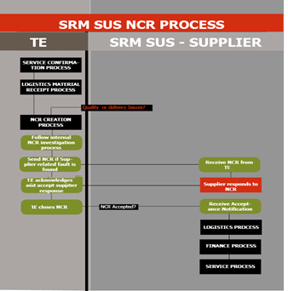

Receiving an NCR
All NCR’s will be sent to the portal using a notification. The supplier central email will receive an email notification:
- Tip: Once the email is received, the supplier will logon to the SRM application to access the notification.

PROCEDURE
Follow the logon instructions in chapter 1.
- Navigate the screen until the Supplier Self Service Page screen is displayed.
- Note: User the menu to access the NCR functionality
Click on the NCR menu item.
A report is used to draw and manage NCR’s. Two NCR’s type will be sent to suppliers:
- A late delivery NCR
- A quality NCR

- Note: The NCR Selection Report screen is Displayed
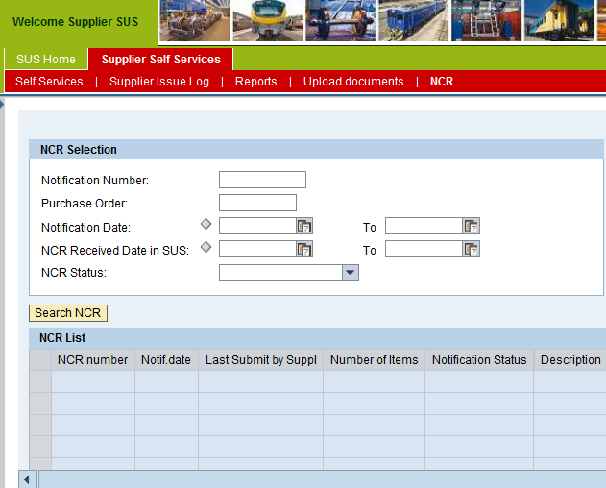
On the report selection screen, enter the following information:
Item | Data Input | Description
Notification Number | e.g. 200023470 | Enter notification number if known, this can be picked up from the email notification from TE.
Purchase Order Number | e.g. 4500000456 | Enter the PO number if known
Notification Date | e.g. 25.07.2012 | Enter notification date if known
NCR Received Date in SUS | e.g. 25.07.2012 | Enter NCR received date if known
NCR Status | e.g. Open | Enter the NCR notification status to filter results by status.

Click on the Search button to continue.
- Note: The NCR List is displayed.
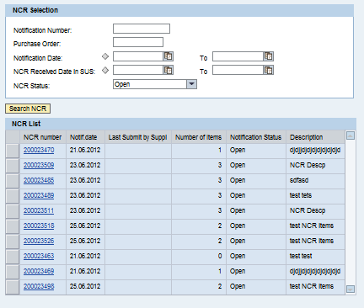

Click on the NCR number to access the NCR details.

Notes
When you access the NCR, an update on the TE system will be made to indicate that you have reviewed the NCR.
TE conduct an internal investigation on ALL NCR’s raised to ensure that the NCR sent to the supplier has been reviewed prior to being sent to the portal.

At this stage it is important to note the following controls in place:

Status | Action |  |  | Screen Enabled or Disabled
 | Can Edit | Can Save | Can Submit | Screen
INIT | Yes | Yes | No | Enabled
NOTT | Yes | Yes | Yes | Enabled
SENT | No | No | No | Disabled
APPR | No | No | No | Disabled
REJE | Yes | Yes | Yes | Enabled

The details below are based on the INIT status, meaning the screen will be completely enabled for all actions.
- Note: The NCR Item Details is displayed
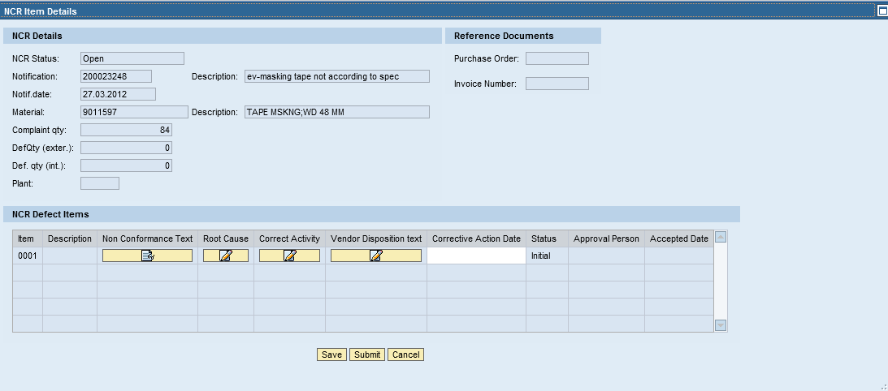
The NCR has important areas the supplier needs to review:
- The NCR number and the description
- The reference PO number and where payment has been made, the reference invoice number
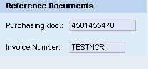
- The details of the defective material or service, as well as the plant where the goods or services were received.
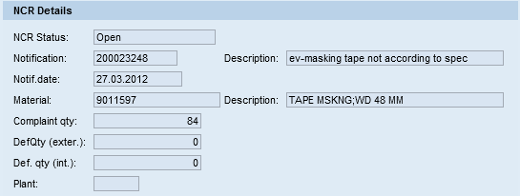
- An area for details of the NCR and for the supplier to respond to the NCR. These are defined below.
Click on the non conformance text to see the contents of the defect from TE 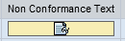
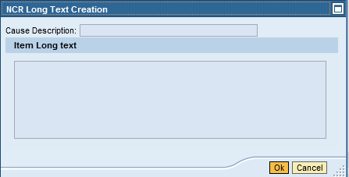
Click on the ok button to continue

Root Cause
Click on the root cause 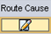 tab to enter the details of the cause
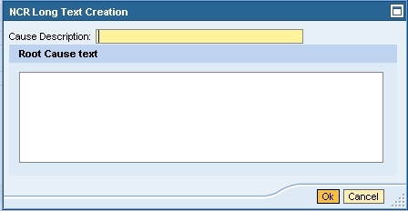
Click on the ok button to continue

Corrective Activity
Click on the corrective activity 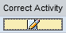 tab to enter the corrective action to be taken for the defect
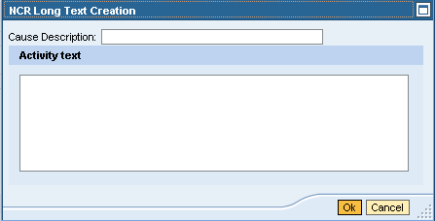
Click on the ok button to continue

Vendor Disposition
Click on the vendor disposition 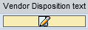 tab to enter the short term resolution for the defect
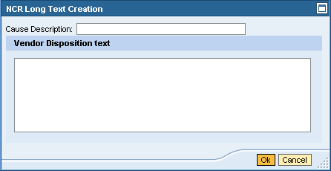
Click on the ok button to continue
Enter the following details:
Item | Data Input | Description
Corrective Action Date | e.g. 30.09.2012 | Enter the exact data when corrective action will be taken for the defect, e.g. new batch of material delivered. The system presents s drop down calendar to use.
Click on the save button to save your entries.

Once you are satisfied with your entries, you may send the NCR response to TE.
Click on the submit button to send the NCR response to TE

TE will close the NCR once you have adhered to the specified response.
Caution
When an NCR is rejected, it will return with the original text from the supplier and the status from the approver in TE.
- When responding, please ensure that you do not delete the original text!
  - Go to the end of the existing text and start typing from that point onwards.
  - Add a date for the new text and below that – enter the response.

FINANCE – INVOICE AND INVOICE STATEMENT SUBMISSION
Course map
This course consists of the following chapters:
 | Chapter | Description
 | 1 | Login on, Passwords and Authorisation Access
 | 2 | Purchase Order Management
 | 3 | Advanced Shipping Notification and Shipping Document
 | 4 | Pre-Receipt Process
 | 5 | Service Confirmation
 | 6 | Supplier Non Conformance Management
 | 7 | Finance – Invoice and Invoice Statement Submission
 | 8 | BBBEE and Tax Clearance Certificates Upload
 | 9 | Tracking and Reporting
 | 10 | SRM SUS Call Log and Support
Learning Outcomes
- Creating a SUS Invoice and supplier invoice attachment
- Creating a SUS Invoice statement and supplier statement attachment
- Managing rejected invoices and invoice statements
- Tracking and Reporting

Overview
This chapter will cover the finance process, and all aspects related to uploading relevant financial documentation to initiate the finance process.

Process Flow
The Process flow below indicates the detailed Finance (Accounts Payable) process as implemented in TE.
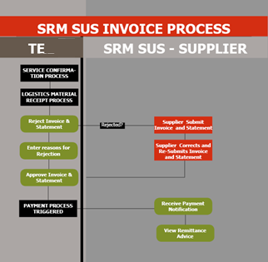

Display List of Supplier Invoices
Overview
All SUS suppliers will be able to submit their invoices after good receipt or service entry sheet approval on SUS. This will ensure timeous receipt of invoices by the finance department and subsequent timeous receipt.
All issues with invoices and statements will be immediately actioned through workflow correspondence from the TE finance department.

PROCEDURE
Follow the logon instructions above.
- You are now on the SRM SUS Landing screen
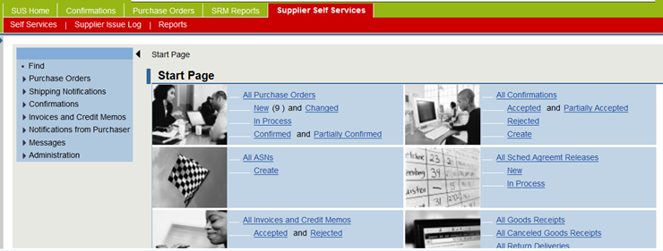
- Use the menu tree is on the left hand side of the screen to access the PO or the work area icon:
If Using the Menu Tree
Click on the Invoices and Credit Memo menu item that will open the menu tree

If Using the Working Area following these instructions:
Click on the All Invoices and Memo’s icon
- Note: You are now on the List of Invoices and Credit Memos screen
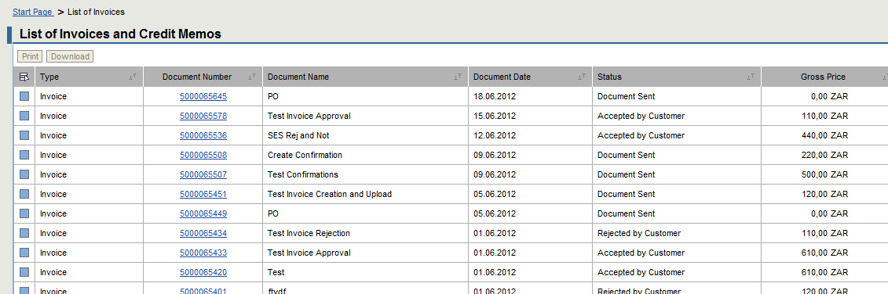
Select the invoice or credit memo you may want to display.

Creating a SUS Invoice for GRV

PROCEDURE
Follow the logon instructions above.
- You are now on the SRM SUS Landing screen
- Use the menu tree is on the left hand side of the screen to access the PO or the work area icon:
If Using the Menu Tree
Click on the Create Invoice menu item
If Using the Working Area
Click on the Create icon under All Invoices and Credit Memos
- You are now on the Create Invoice screen
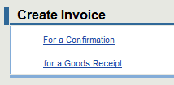
Notes
The system allows you to create an invoice for a confirmation (service rendered) or for goods receipt (material delivered).

PROCEDURE
Click on the option to create an invoice for a GRV
- You are now on the List of GRV screen with the document name GR for a goods PO
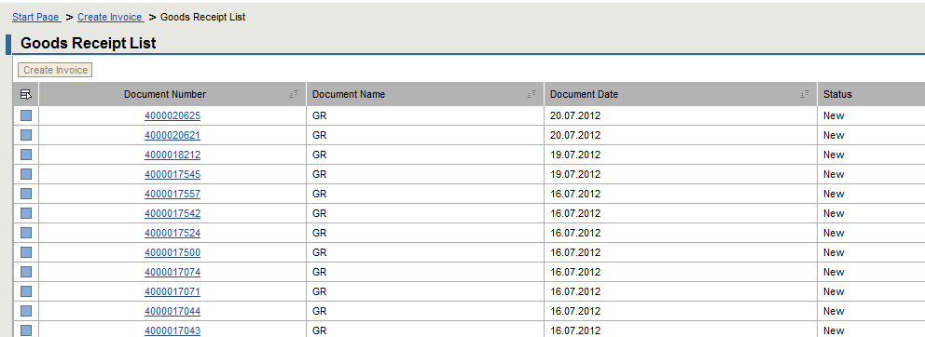
Click on the Document number you with to create an invoice for.
- Caution: The document (PO) will only appear on this list if the GRV has been completed by TE.
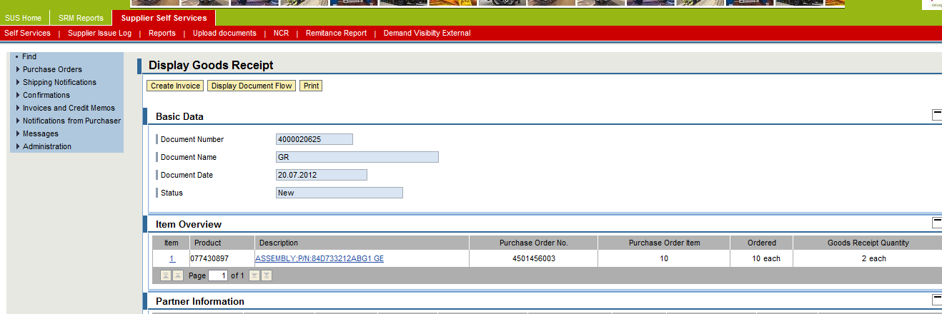
- Note: The PO number is displayed on the Basic Data area of the screen
Click on Create Invoice button to create an invoice.
- Note: The Process Invoice screen is displayed.
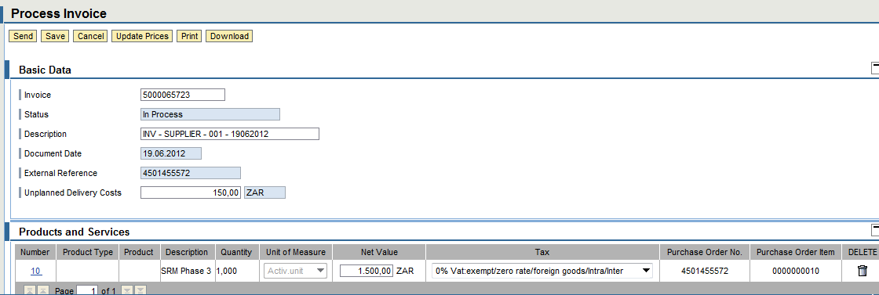
Enter the following information:
Item | Data Input | Description
Description | Enter Invoice Reference number, e.g. INV - SUPPLIER - 001 - 19062012 | Enter the invoice number under description -
- Prefix with the centre responsible, followed by your company name, e.g. KDS – ABCSUPPLIES – your statement reference.
  - A table of centre prefixes is provided below for your reference.
CENTRE | PREFIX
KILNER PARK | KLP
SALT RIVER | SRX
UITENHAGE | UTH
BLOEMFONTEIN | BFX
DURBAN | DBN
GERMISTON | GMX
KOEDOESPOORT | KDS

Unplanned Delivery Costs | Enter any unplanned delivery costs where relevant, e.g. R150.00 | Enter any unplanned delivery costs if necessary
- Note: The conditions will change to match any net value changes or delivery costs changes made on the invoice screen.
Tax | Select the relevant tax for your invoice from the drop down menu. | Select the relevant tax for your invoice:
- Note: Should the invoice be for selected lines, delete those lines that are not being invoiced by clicking on the delete icon on the line item. 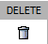
- Warning: All SRM SUS invoices must be accompanies by a company Invoice and an Invoice Statement.

Attaching and Invoice and Invoice Statement
Scroll to the bottom of your screen to attach your documentation.
Caution
The following rules apply for attachments:
- Only PDF files will be accepted
- The maximum allowed size for attachments is 700KB
Click on Add Attachments button to add your Invoice and Statement.
The browse functionality will appear at the bottom of the screen. You may browse and attach your documentation.
Click on the Upload button to add your attachment.
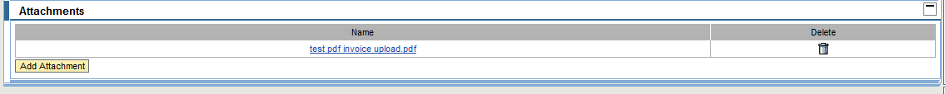
- Note: The attachment is displayed on the list of attachments.
Notes
- Once the file is uploaded it will appear on the attachment list.
- Should a mistake have been done, the delete icon on the right can be used to remove the attachment.
- Multiple attachments may be uploaded.
- Where the incorrect file type is used, the system will not upload the document and give a message at the top of the screen in the messages area. 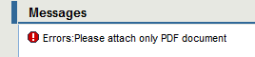
Click on the Upload button to add your attachment.
- Caution: Check all your entries and attachments.
Click the Save button to save your changes.
Click the Send icon to send the Invoice to TE.
The message is displayed. This message indicates that your changes have been successfuly adopted and sent to TE for acceptance or rejection.

Notes
- The system will not allow you to send the invoice without an attachment.

Creating a SUS Invoice for a Services

PROCEDURE
Click on the Create Invoice menu item
If Using the Working Area
Click on the Create icon under All Invoices and Credit Memos
- You are now on the Create Invoice screen
Click on the option to create an invoice for a Confirmation
- You are now on the List of Confirmations screen
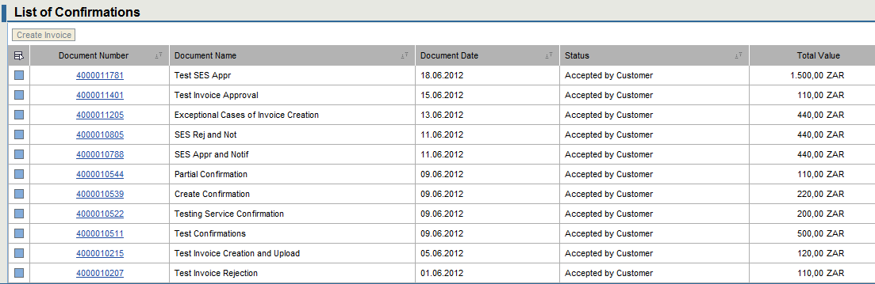
Click on the confirmation document number you with to create an invoice for.
- Caution: The document (PO) will only appear on this list once the Service Entry Sheet has been accepted by TE.
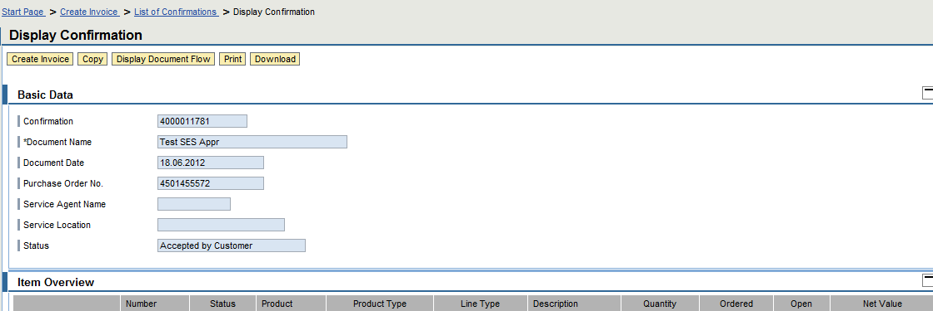
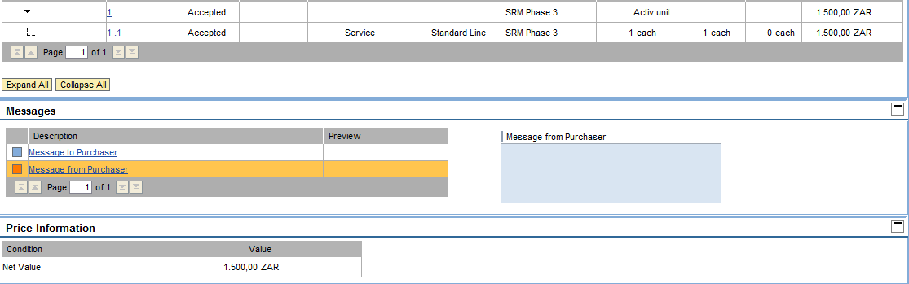
- Note: The PO number is displayed on the Basic Data area of the screen
Click on Create Invoice button to create an invoice.
- Note: The Process Invoice screen is displayed.
Enter the following information:
Item | Data Input | Description
Description | Enter Invoice Reference number, e.g. INV - SUPPLIER - 001 - 19062012 | Enter the invoice number under description -
- Prefix with the centre responsible, followed by your company name, e.g. KDS – ABCSUPPLIES – your statement reference.
  - A table of centre prefixes is provided below for your reference.
CENTRE | PREFIX
KILNER PARK | KLP
SALT RIVER | SRX
UITENHAGE | UTH
BLOEMFONTEIN | BFX
DURBAN | DBN
GERMISTON | GMX
KOEDOESPOORT | KDS

Unplanned Delivery Costs | Enter any unplanned delivery costs where relevant, e.g. R150.00 | Enter any unplanned delivery costs if necessary
- Note: The conditions will change to match any net value changes or delivery costs changes made on the invoice screen.
Tax | Select the relevant tax for your invoice from the drop down list. | Select the relevant tax for your invoice:
- Note: Should the invoice be for selected lines, delete those lines that are not being invoiced by clicking on the delete icon on the line item.
- Warning: All SRM SUS invoices must be accompanied by a company Invoice and an Invoice Statement.

Attaching and Invoice and Invoice Statement
Scroll to the bottom of your screen to attach your documentation.
Caution
The following rules apply for attachments:
- Only PDF files will be accepted
- The maximum allowed size for attachments is 700KB
Click on Add Attachments button to add your Invoice and Statement.
The browse functionality will appear at the bottom of the screen. You may browse and attach your documentation.
Click on the Upload button to add your attachment.
- Note: The attachment is displayed on the list of attachments.
Notes
- Once the file is uploaded it will appear on the attachment list.
- Should a mistake have been done, the delete icon on the right can be used to remove the attachment.
- Multiple attachments may be uploaded.
- Where the incorrect file type is used, the system will not upload the document and give a message at the top of the screen in the messages area.
Click on the Upload button to add your attachment.
- Caution: Check all your entries and attachments.
Click the Save button to save your changes.
Click the Send icon to send the Invoice to TE.
The message is displayed. This message indicates that your changes have been successfuly adopted and sent to TE for acceptance or rejection.
Click on the Create Invoice menu item
If Using the Working Area
Click on the Create icon under All Invoices and Credit Memos
- You are now on the Create Invoice screen

Uploading Statements
Statements are uploaded separately from Invoices. The instructions below are valid for goods and services.

PROCEDURE
Follow the logon instructions above.
- You will be directed to the SRM SUS Landing screen
The upload functionality is located on the header.
Click on the upload documents menu option to access the upload functionality

- Note: The Upload Detailed Navigation screen is displayed
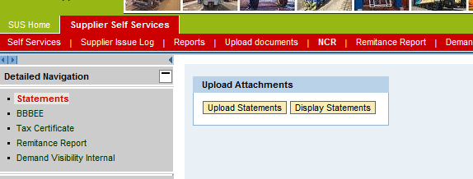
Click on Statements item to access the Invoice Statements upload functionality
- Note: You are now in the Upload Attachments screen for Statements
You have two options:
- To upload new attachments
- To display existing uploaded attachments
Click on upload statements button to add a new Statement
- Note: The Attachment Overview screen is displayed
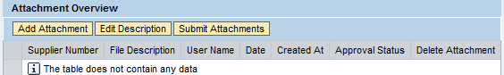
Click on the Add Attachment button to add a new Statement

- Note: The Add Attachment pop-up is displayed
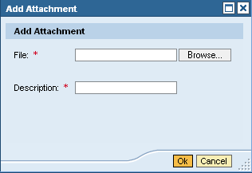
Caution
The following rules apply for the description:
- Prefix with the centre responsible, followed by your company name, e.g. KDS – ABCSUPPLIES – your statement reference.
  - A table of centre prefixes is provided below for your reference.
- Remember, TE’s Finance department receives thousands of statements and to ensure the right people are reviewing your statement, you have to ensure that it is properly prefixed.

CENTRE | PREFIX
KILNER PARK | KLP
SALT RIVER | SRX
UITENHAGE | UTH
BLOEMFONTEIN | BFX
DURBAN | DBN
GERMISTON | GMX
KOEDOESPOORT | KDS
Select the file you want to attach from your computer
Caution
The following rules apply for attachments:
- Only PDF files will be accepted
- The maximum allowed size for attachments is 700KB
The attachment is displayed on the Attachment Overview screen.
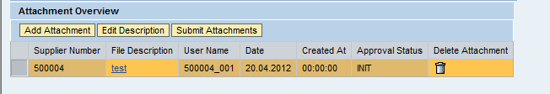
You can add multiple attachments as below, or you can use the delete icon to remove any mistakes made, or to replace uploaded attachment.
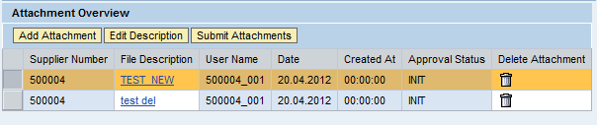
Click on submit attachment button to send the attachment to TE’s finance department.

Displaying Statements
Click on display statements button to display existing statements
- Note: The List of Statements screen is displayed
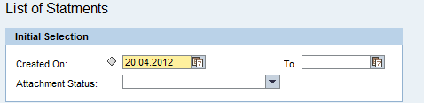

Enter the following information
Item | Data Input | Description
Created on | e.g. 30.05.2012 | Enter statement creation date date as a single value or range. The system provides a calender for selection.
Attachement Status | E.g.INIT (for initial) | Enter the status of the statements you would like to view.
Click on the button to execute the report
- Note: The Statements Report is displayed
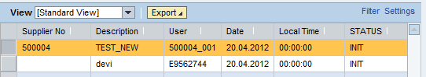

Managing Rejected Invoices and Statements

PROCEDURE
The list of invoices and credit memos will depict the rejected and accepted invoices.
In addition to that when an invoice is rejected, a notification will be sent from TE to the supplier to communicate the rejection.

View Accepted Invoices

PROCECURE
Click on the icon to view the accepted invoices and memos
- Note: You are now on the List of Approved Invoices and Credit Memos screen
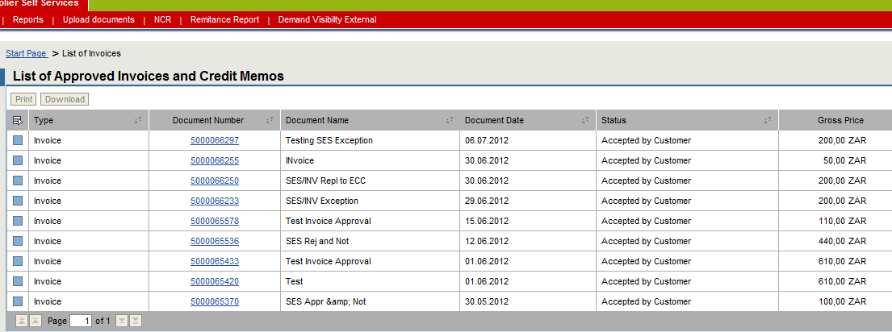
You can click on the document number to view the details of the document.

View Rejected Invoices

PROCECURE
Click on the icon to view the rejected invoices and memos
- Note: You are now on the List of Rejected Invoices and Credit Memos screen
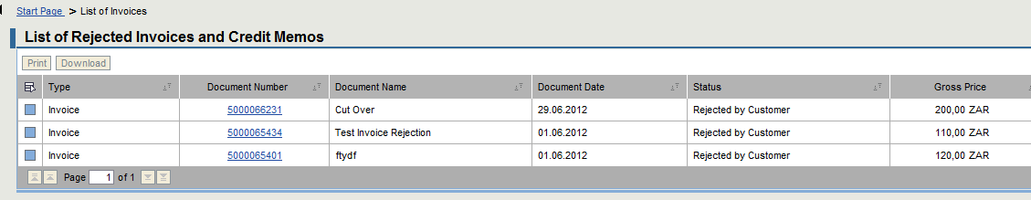
You can click on the document number to view the details of the document.
The reasons for rejection as per the notification will be displayed on the Rejection Reason column.
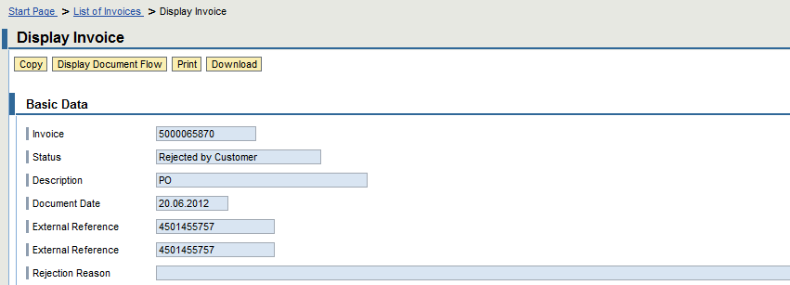
- Note: To assist the supplier, when rejecting TE will put a finance representative name, email and telephone number on the reasons for rejection.
- Note: Should the reasons not be clear, you may contact this person for further assistance.

The credit memo will be managed in the same manner as the Invoice.
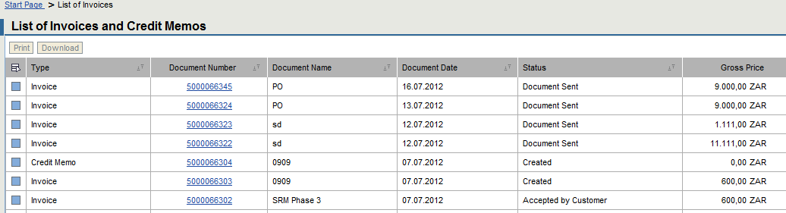
When viewing the details, the structure is exactly like the invoice structure.
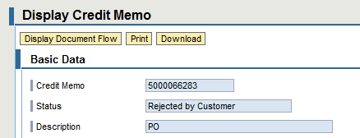

Checking Payment Statuses on Invoices

PROCEDURE
Follow the logon instructions above.
- You are now on the SRM SUS Landing screen
- Use the menu tree is on the left hand side of the screen to access the PO or the work area icon:
If Using the Menu Tree
Click on the Invoices and Credit Memo menu item that will open the menu tree
If Using the Working Area
Click on the All Invoices and Memo’s icon

- Note: You are now on the List of Invoices and Credit Memos screen
Click on Invoice document number you would like to view
- Note: The Display Invoice screen is displayed.
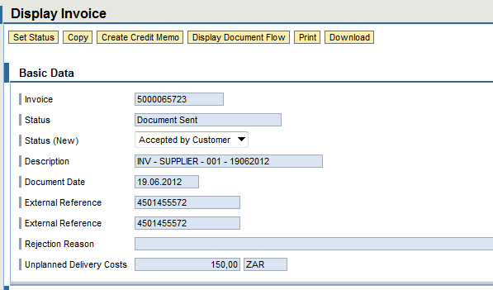
Scroll to the bottom until you see Payment Status Information.
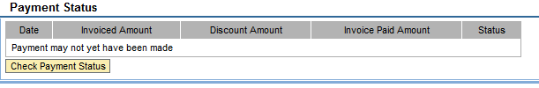
Click on Check Payment Status button to check if payment has been made.

The Remittance Advice

PROCEDURE
Follow the logon instructions above.
- You are now on the SRM SUS Landing screen
The remittance advice is located on the header.
Click on the remittance report menu option to access the remittance reports
- Note: The Remittance Advice Report is displayed
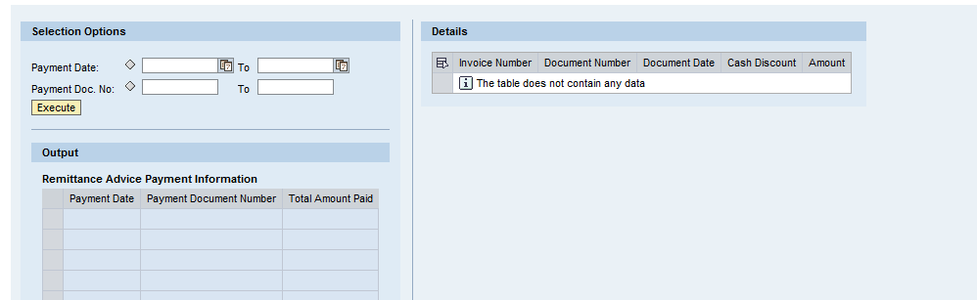

Enter the following information:
Item | Data Input | Description
Payment Date | e.g. 30.05.2012 | Enter payment date as a single value or range. The system provides a calender for selection.
Payment Doc Number | Enter payment doc number | Enter payment doc number
Click on the execute button to run the report
- Note: The Remittance Advice Payment Information Output is displayed at the bottom of the page
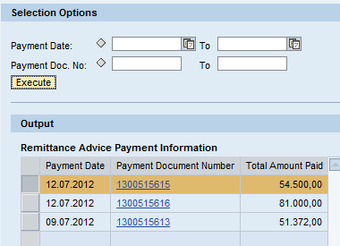

Click on the payment document number to view he details of the payment
- Note: The Details of the Document is displayed on the right of the page
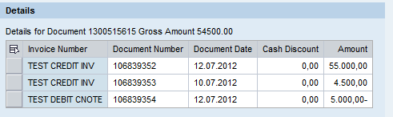

Notes
The remittance advice cannot be printed on SRM SUS. This is merely for display purposes.

BBBEE AND TAX CLEARANCE CERTIFICATES UPLOAD
Course map
This course consists of the following chapters:
 | Chapter | Description
 | 1 | Login on, Passwords and Authorisation Access
 | 2 | Purchase Order Management
 | 3 | Advanced Shipping Notification and Shipping Document
 | 4 | Pre-Receipt Process
 | 5 | Service Confirmation
 | 6 | Supplier Non Conformance Management
 | 7 | Finance – Invoice and Invoice Statement Submission
 | 8 | BBBEE and Tax Clearance Certificates Upload
 | 9 | Tracking and Reporting
 | 10 | SRM SUS Call Log and Support

Learning Outcomes
- Uploading a BBBEEE Certificate
- Uploading the Tax Clearance Certificate
- Managing rejected submissions

Overview
This chapter will cover annual uploading of statutory documentation by suppliers. Without these documents, your business with Transnet Engineering will be greatly hampered. The SRM SUS application allows for the TE system to send suppliers notifications for expirations of their statutory documentation so as to ensure continuous compliance.

Process Flow
The Process flow below indicates the detailed BBBEE and Tax Clearance Submission process as implemented in TE.
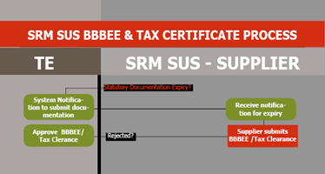

Uploading BBBEE Certificates

PROCEDURE
Follow the logon instructions above.
- You will be directed to the SRM SUS Landing screen
The upload functionality is located on the header.
Click on the upload documents menu option to access the upload functionality
- Note: The Upload Detailed Navigation screen is displayed
Click on BBBEE item to access the BBBEE upload functionality
- Note: You are now in the Upload Attachments screen for BBBEE Certificates
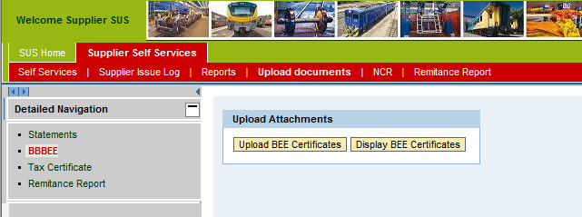You have two options:
- To upload new certificates
- To display existing uploaded certificates
Click on upload BBBEE Certificate button to add a new certificate
- Note: The Attachment Overview screen is displayed
Click on the Add Attachment button to add a new Statement
- Note: The Add Attachment pop-up is displayed
Caution
The following rules apply for the description:
- Prefix with the name of the certificate, followed by your company name, e.g. BBBEE- ABCSUPPLIES – your certificate reference.
- Remember, TE receives thousands of certificates and to ensure the right people are reviewing your certificate you have to ensure that it is properly prefixed.
Select the file you want to attach from your computer
Caution
The following rules apply for attachments:
- Only PDF files will be accepted
- The maximum allowed size for attachments is 700KB

The attachment is displayed on the Attachment Overview screen.
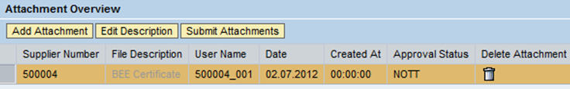
You can add multiple attachments as below, or you can use the delete icon to remove any mistakes made, or to replace uploaded attachment.
Click on submit attachment button to send the attachment to TE’s finance department.
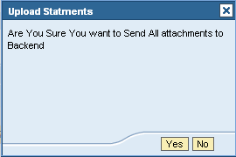
Click on the yes button to send the attachment to TE.

By clicking on the button, all existing BBBEE certificates will be made available to supplier for display.
Enter the required selection criteria and click on search documents to execute the report.

Notes
The attachments will be sent to TE and the following will take place:
- If the contents of the attachments are accurate, the team will ACKNOWLEDGE receipt first. The supplier will be sent an acknowledgement of receipt through their central email address.
- Where a certificate is rejected, the supplier will receive reasons for the rejection and they will be required to submit a corrected certificate.
- Within 7 days of acknowledgement, TE will ACCEPT/APPROVE the BBBEE certificate. This will also be sent through the suppliers central email address.
- Annually, prior to expiry of the certificate, TE will send reminders and pop-ups to the supplier to ensure that the supplier updates their certificates timeously.
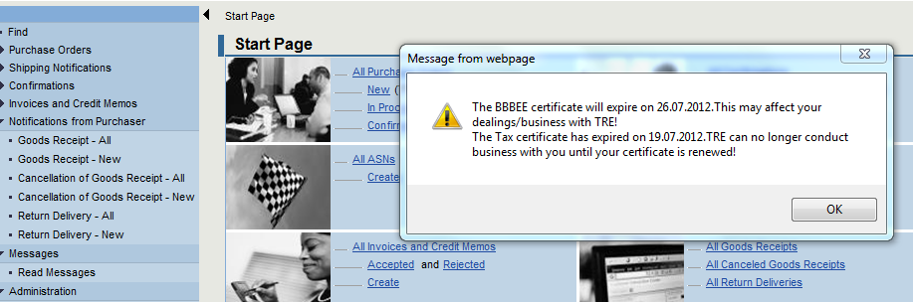

Uploading Tax Clearance Certificate Certificates

PROCEDURE
Follow the logon instructions above.
- You will be directed to the SRM SUS Landing screen
The upload functionality is located on the header.
Click on the upload documents menu option to access the upload functionality
- Note: The Upload Detailed Navigation screen is displayed
Click on Tax Clearance item to access the Tax Clearance upload functionality
- Note: You are now in the Upload Attachments screen for BBBEE Certificates
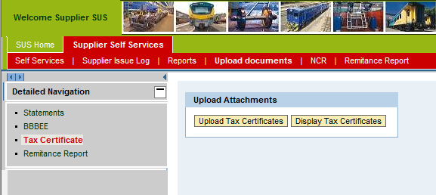
You have two options:
- To upload new certificates
- To display existing uploaded certificates
Click on upload a tax clearance certificate button to add a new certificate
- Note: The Attachment Overview screen is displayed
Click on the Add Attachment button to add a new Statement

- Note: The Add Attachment pop-up is displayed
Caution
The following rules apply for the description:
- Prefix with the name of the certificate, followed by your company name, e.g. TAXCERT- ABCSUPPLIES – your certificate reference.
- Remember, TE receives thousands of certificates and to ensure the right people are reviewing your certificate you have to ensure that it is properly prefixed.

Select the file you want to attach from your computer
Caution
The following rules apply for attachments:
- Only PDF files will be accepted
- The maximum allowed size for attachments is 700KB

The attachment is displayed on the Attachment Overview screen.
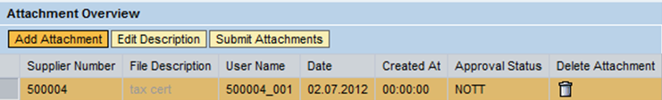
You can add multiple attachments as below, or you can use the delete icon to remove any mistakes made, or to replace uploaded attachment.
Click on submit attachment button to send the attachment to TE’s finance department.
Click on the yes button to send the attachment to TE.

By clicking on the button, all existing Tax Clearance certificates will be made available to supplier for display.

Enter the required selection criteria and click on search documents to execute the report.
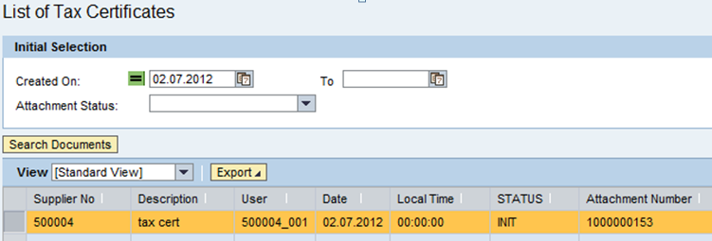
Notes
The attachments will be sent to TE and the following will take place:
- If the contents of the attachments are accurate, the team will ACKNOWLEDGE receipt first. The supplier will be sent an acknowledgement of receipt through their central email address.
- Where a certificate is rejected, the supplier will receive reasons for the rejection and they will be required to submit a corrected certificate.
- Within 7 days of acknowledgement, TE will ACCEPT/APPROVE the BBBEE certificate. This will also be sent through the suppliers central email address.
- Annually, prior to expiry of the certificate, TE will send reminders and pop-ups to the supplier to ensure that the supplier updates their certificates timeously.

TRACKING AND REPORTING
Course map
This course consists of the following chapters:
 | Chapter | Description
 | 1 | Login on, Passwords and Authorisation Access
 | 2 | Purchase Order Management
 | 3 | Advanced Shipping Notification and Shipping Document
 | 4 | Service Confirmation
 | 5 | Supplier Non Conformance Management
 | 6 | Finance – Invoice and Invoice Statement Submission
 | 8 | BBBEE and Tax Clearance Certificates Upload
 | 9 | Tracking and Reporting
 | 10 | SRM SUS Call Log and Support

Overview
This chapter will cover the tracking and reporting for suppliers. All the various
Learning Outcomes
- Additional Reporting for Suppliers not covered in the specific chapters

Demand Visibility Report
TE has created a demand visibility report for materials that may be urgently required. You may use this and contact you Procurement Official for more details on how to quote for the material(s).

Warning
This is a specific demand that looks at the following:
- Your supplier ID
- If you have a contract for the material in demand
- If there is no PO for the demand in the system yet.
YOU WILL NOT BE ABLE TO SEE ALL DEMAND IN TRE – ONLY THOSE ITEMS SPECIFC TO YOUR EXISTING CONTRACT.

PROCEDURE
Follow the logon instructions above.
- You will be directed to the SRM SUS Landing screen
The upload functionality is located on the header.
Click on the Supplier Self Service menu option to demand visibilityNote: The Upload Detailed Navigation screen is displayed
Click on Demand Visibility External item to access the report
- Note: You are now in the Demand Forecast Visibility screen
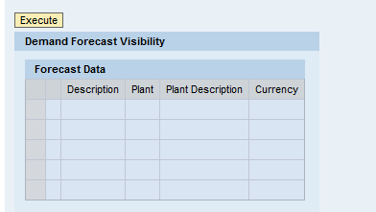
Click on the execute button to continue
If there is any demand to be presented to the supplier, it will be presented in a tabular format.
- Note: The Demand Forecast Visibility Report results are display
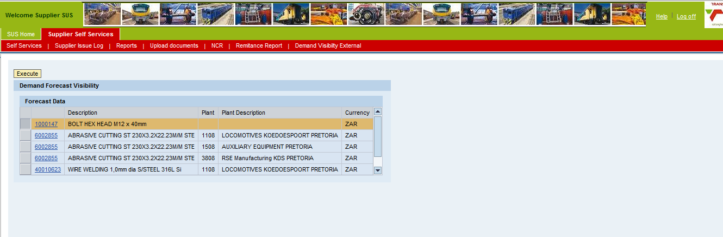
Click on material number you would like to see the requirements for
- Note: The Demand Forecast Visibility Detail view is displayed on the right
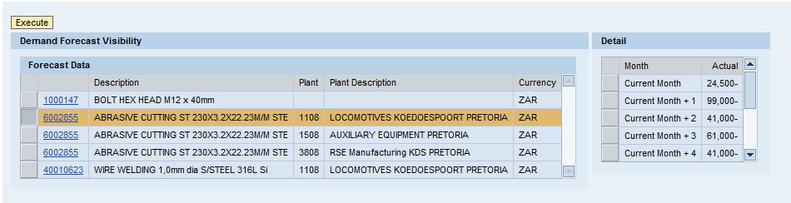

SRM SUS CALL LOG AND SUPPORT
Course map
This course consists of the following chapters:
 | Chapter | Description
 | 1 | Login on, Passwords and Authorisation Access
 | 2 | Purchase Order Management
 | 3 | Advanced Shipping Notification and Shipping Document
 | 4 | Service Confirmation
 | 5 | Supplier Non Conformance Management
 | 6 | Finance – Invoice and Invoice Statement Submission
 | 7 | Tracking and Reporting
 | 8 | BBBEE and Tax Clearance Certificates Upload
 | 9 | Tracking and Reporting
 | 10 | SRM SUS Call Log and Support
Learning Outcomes
- PDF as the required format for attachments
- Logging a call through SRM SUS
- TE Support for SRM SUS Queries

Overview
This chapter will cover the support aspect of SRM SUS. Suppliers can now log a call through the SUS portal. This chapter also covers the overall support by Transnet Engineering.

PDF Attachments
The SRM SUS system will require all their transaction uploads to be PDF. The only exception is the call logging functionality.
PDF is a free tool that can be downloaded from the internet. The following sites can be used for this:
- www.adobe.com/AcrobatX/
- http://get.adobe.com/uk/reader/
- Or you can use google.com to search for your preferred site for downloads

Once you have ADOBE installed, you can go to printing your document and adobe will be loaded as a printer.
Select the adobe printer; you will be prompted to give a document name.
Save it on your machine and upload it on SRM SUS.

Logging a Call through SRM SUS
The new enhancements on the portal allows for the SRM SUS call to be logged.
This is recommended as you will receive call reference number and these are tracked and actively managed.

PROCEDURE
Click on the Supplier issue log 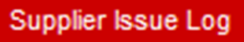 tab to access the call logging functionality
- You are now on the Supplier Log/Call Log screen
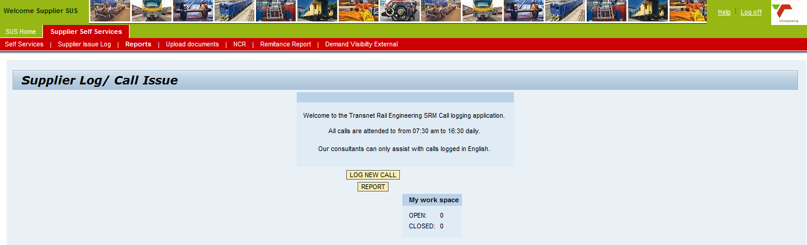
The screen will display any open reports and all closed reports under your user id. This represents your user id completed call history.
To log a new call:
Click on the log new call button to log a new call
- Note: The Supplier Call Logging screen is displayed
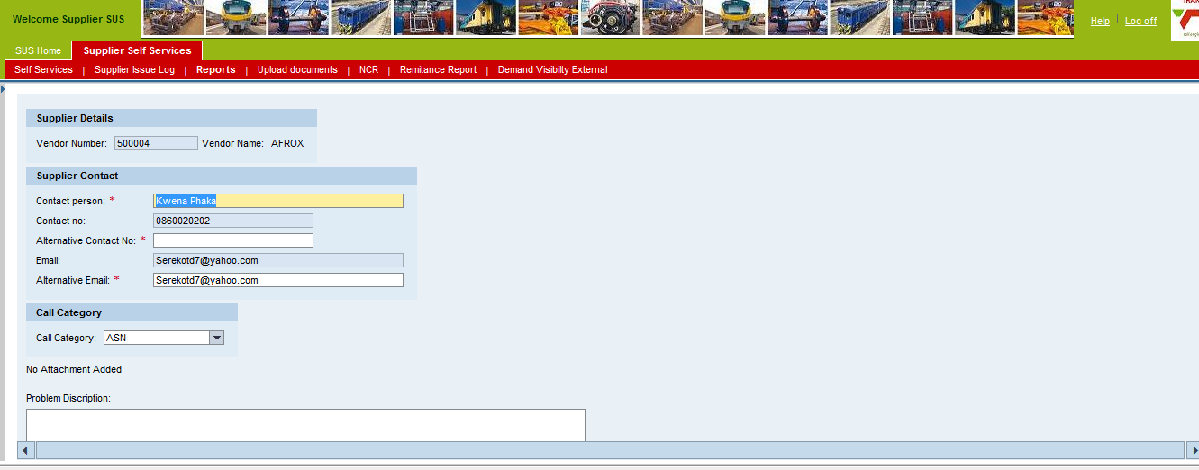
Enter the following Information:

Item | Data Input | Description
Contact Name | Enter your contact name if different from defaulted name | The system will default the name captured under the user-id.  This name is not updated in the master data; it’s purely for call logging purposes.
Alternative Contact Number | e.g. 082 222 222 | Enter the alternative call number. If the same as the default number, you need to enter it again. This is the call a TE representative will call you on regarding your call.
Alternative Contact E-Mail | e.g. 123@gmail.com | Enter the alternative email number. If the same as the default email address, you need to enter it again. This is the call a TE representative will use to contact you regarding your call.
Call Category | e.g. ASN | Select the relevant call category for your query from the drop down list. TE has created default categories to be able to assist you quicker.
Problem Description | Enter your problem description | This is the long text of the problem you may be having.  - The long text does not perform automatic spell check.  - The long text should not be in SMS language  - The long texts should not be longer than 500 characters.

Attachments
In instances where the supplier would like to send screen shots/prints or would like to send more information, multiple attachments can be made.
Click on the add/view attachment button to add attachments or to edit, view, replace or delete any existing attachments
- Note: The Add Attachment screen is displayed
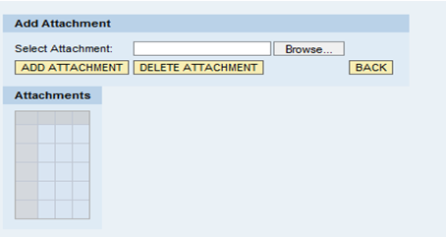
Click on the browse button to find your attachment.
Click on the add attachment button to continue.
The message is displayed and the attachement is added to the attachments table.
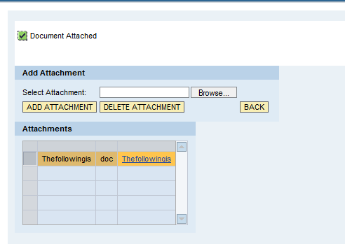
Notes
This is the only attachment allowed by TE that can be different file types. The following is allowed:
- Text
- Microsoft Word
- Microsoft Excel
- PDF
The file size is still limited to 700KB.

If you need to replace the attachment, then you can use the delete attachement button to remove the existing attachement.
Click on the back button to return to the call log menu
Click on the submit button to submit the
The message 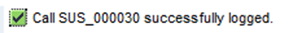is displayedto indicate that the call is logged and the call reference number is made available.

Logging a call with the Help Desk
To log a call with the help desk, follow these two options:

EMAIL:
Email the Supplier Support team on Supplier.Support@transnet.net

PHONE:
Call the Supplier Support line on+27 12 391 1397

Escalating Call Response or Issues
If you do not receive the expected response from our support team then the following avenues should be used:

EMAIL:
- Email the Continuous Improvement Senior Manager, Cwayita Sihele on Cwayita.Sihele@transnet.net
- Email the SAP Support Senior Manager, Zelda Motloung on Zelda.Motloung@transnet.net
- Copy any escalation emails to the Change Management Team on Supplier. SelfService@transnet.net. PLEASE NOTE: This email is checked once a week and should never be used for first line support queries.

Transnet is committed to ensuring that we give the appropriate and required support to our suppliers and as such, we do not hesitate to escalate any issues you may have when required.

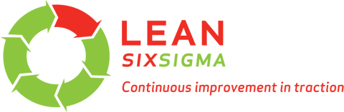
THANK YOU FOR YOUR ATTENDANCE

