Required access
Purchase Order | SRM0000.Procument
Shipping | SRM0000.logistics
Invoicing | SRM0000.Finance
Non Conformance Reporting | SRM0000.NCR

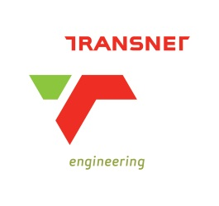
Application for SRM-SUS

Note: Please fill-in this form, scan and send it to Supplier.support@transnet.net

For assistance with completing the form, please call the support line on 012 391 1397

Incomplete form will not be processed

Date: _____________________

Vendor name: _________________________________________________________________

Vendor Number: ______________________________________________________________

Title: _____First name: ___________________Surname: ______________________________

ID Number: ___________________________________________________________________

E-mail: ______________________________________________________________________

Phone: __________________________________Cell: _________________________________

Are you in possession of the training material Yes No

New Supplier Information (If applicable):

Contact Person:

Email Address:

Telephone Number:

Document Name:
Release date:
OCTOBER 2012
SRM APLICATION FORM Document No.:
Version No.
Page:
SM_NAT_PROC_FRM_5
0-0
1 of 1

For Office Use
NAME
DATE
SIGNITURE

Fax Number:

I certify that the above information is correct and I acknowledge that I will be responsible for any
transaction done on my username.

I further declare that I will abide by the Transnet information security policy as published on the
SRM-SUS portal.

Signature of Applicant: _________________________________

Date: _______________________________________________

Document Name:
Release date:
OCTOBER 2012
SRM APLICATION FORM Document No.:
Version No.
Page:
SM_NAT_PROC_FRM_5
0-0
2 of 1

Thank you for evaluating Wondershare PDF Editor.

You can only convert 5 pages with the trial version.

To get all the pages converted, you need to purchase the software from:

http://cbs.wondershare.com/go.php?pid=1140&m=db

